**A report submitted in partial fulfilment of the regulations governing the award of**

**the Degree of**

**BSc. (Honours) Computer Science with Games Development at the University of Northumbria at Newcastle**

**Project Report**

**A Study of How Interaction with a Video Game Dynamic Difficulty Adjustment System Affects Accessibility and Player Experience for Individuals Aged 20 – 30**

**Scott Spoors – w20003739**

**2022 / 2023**

# Authorship Declaration

**DECLARATIONS**

I declare the following:

1. That the material contained in this dissertation is the end result of my own work and that due acknowledgement has been given in the bibliography and references to **ALL** sources be they printed, electronic or personal.
2. The Word Count of this Dissertation is 13,124
3. That unless this dissertation has been confirmed as confidential, I agree to an entire electronic copy or sections of the dissertation to be placed on the eLearning Portal (Blackboard), if deemed appropriate, to allow future students the opportunity to see examples of past dissertations. I understand that if displayed on eLearning Portal it would be made available for no longer than five years and that students would be able to print off copies or download.
4. I agree to my dissertation being submitted to a plagiarism detection service, where it will be stored in a database and compared against work submitted from this or any other School from other institutions using the service.

In the event of the service detecting a high degree of similarity between content within the service this will be reported back to my supervisor and 2nd marker, who may decide to undertake further investigation that may ultimately lead to disciplinary actions, should instances of plagiarism be detected.

1. I have read the Northumbria University/Engineering and Environment Policy Statement on Ethics in Research and Consultancy and I confirm that ethical issues have been considered, evaluated and appropriately addressed in this research.

SIGNED:

SCOTT SPOORS



# Acknowledgements

I would like to acknowledge the contributions and previous supervision efforts of Dr Mark Hurrell, who initially acted as the supervisor of this project before his departure from the university, for his helpful advice and direction that made many areas of this project progress very smoothly and allowed many new concepts and thoughts to be introduced into the project that helped shape it into what it is now.

Additionally, I would like to acknowledge Dr Yulei Li, who picked up the supervision of this project after Mark departed the university excellently, and provided extremely helpful ideas for the participant investigation methodology as well as very useful feedback on sections of the project report.

# Abstract

In video games, a Dynamic Difficulty Alteration (DDA) system is a system integrated into a video game that allows for constant, spontaneous adjustment of the in-game difficulty level based on a number of factors, such as player performance. This study aimed to research the how the interaction with a DDA system alters the player experience of playing a game, as well as how this interaction alters the accessibility of the game as compared to playing the game without this DDA interaction. To do this, research into the current academic field surrounding DDA systems was carried out, from which an Unreal Engine 4 game demo, including an integrated DDA system, and a set of research materials were constructed to be used in a participant investigation into the subject. Results from this investigation showed much promise into confirming that there is a significant, largely positive change to player experience when interacting with the DDA system, and that interaction with this system noticeably improved accessibility for aspects of the demo’s gameplay for certain players.

Table of Contents

Authorship Declaration 2

Acknowledgements 3

Abstract 4

Introduction 7

Research and Planning 8

Literature Review 8

Introduction 8

Origins of the Research Field into DDA 8

Potential Problems of DDA Integration 9

Previous DDA Research Implementations 10

Differences in Player Dynamic 12

Keystroke Dynamics 12

Project Approach Justification 13

Investigation Approach/Research Strategy 13

Practical Work 15

Design 15

Introduction 15

Game Demo Research Material Development 16

Participant Research Design 18

Investigation 20

Results 22

Evaluation 28

Evaluation of Findings 29

Evaluation of Project Process 31

Conclusions and Recommendations 32

Reference List 34

Bibliography 37

Appendices 41

Appendix 1 – Terms of Reference Document 41

Appendix 2 – Game Demo Research Material 56

Appendix 2.1 – Game Demo Screen Captures 57

Appendix 3 – Participant Demographic Survey 60

Appendix 3.1 – Demographic Survey Microsoft Forms Link 60

Appendix 3.2 – Demographic Survey Responses Link 60

Appendix 4 – Game Experience Questionnaire 60

Appendix 4.1 – GEQ Microsoft Forms Link 60

Appendix 4.2 – GEQ Responses Link 60

Appendix 5 – Game-Generated Participant Playthrough Data 60

Appendix 5.1 – Participant 1 Data 61

Appendix 5.2 – Participant 2 Data 61

Appendix 5.3 – Participant 3 Data 62

Appendix 5.4 – Participant 4 Data 63

Appendix 5.5 – Participant 5 Data 64

Appendix 5.6 – Participant 6 Data 65

Appendix 5.7 – Participant 7 Data 65

Appendix 5.8 – Participant 8 Data 66

Appendix 5.9 – Participant 9 Data 67

Appendix 5.10 – Participant 10 Data 68

# Introduction

For many gamers, the level of challenge offered by a game can be one of the most significant factors contributing to if they would be interested in putting their time into it. The topic of how to develop difficulty systems for video games that provide enjoyable challenge levels for all types of players whilst remaining appropriately balanced is a widely discussed issue within the game development industry, with the concept of the Dynamic Difficulty Adjustment (DDA) system becoming an increasingly popular solution to this issue in recent years. Standard difficulty systems involve a more static system of difficulty in which the player will select a chosen level of difficulty at the beginning of a new playthrough, usually between a choice between three discrete difficulty levels – Easy, Normal, and Hard – and the game will remain at this level of difficulty for the duration of said playthrough. Unlike this, a DDA system will allow the difficulty of the game to be altered throughout the course of the playthrough at any required point with significantly more subtle, incremental alterations to the difficulty level than a standard static difficulty system. This is still a rarely implemented system in most commercial video games, with most developers choosing to stick to static systems. The field of academic research on the topic is still relatively young with only small amounts of academic research currently published, but the work that has been done into studying the implementation and effects of DDA systems have proved promising.

This project aimed to study how the use of, and interaction with, a DDA system alters the overall player experience and the accessibility of a video game as opposed to interacting with the same game without this DDA interaction. Due to the circumstances of this project’s development, the focus of this research was placed on the demographic of individuals aged between 20 and 30, both as this demographic was likely to include a large range of individuals with differing levels of pre-existing experience playing video games and as this age range would be simple to gain a range of participants to participate in an investigation to test this research question.

To facilitate this research, first a range of pre-existing academic literature was gathered from within the field of DDA studies as well as from related academic fields from which inspiration may have been gathered. Once this literature review was completed, development of a series of research materials to be used in the participant investigation – primarily focused on the development of an Unreal Engine 4 based video game demo with an integrated DDA system. To streamline development of this demo, the Blueprint Visual Scripting system was utilised as well as an Unreal Engine 4 open source Top-Down Shooter template framework that provided basic movement and shooting code for the game as well as a set of free-to-use assets, which allowed for the development of the game elements needed for interaction with the DDA system – alongside the development of the DDA system itself – to be prioritised. During the planning of the development of the game demo and DDA system, the limitation that the DDA system could not feature automation became quickly apparent, however this limitation became a point of uniqueness in this research, as it could now be researched how manual control over this dynamic difficulty system may differently affect the player experience and accessibility of a game, as compared to the previous research surrounding automated DDA systems.

After the conclusion of the demo and DDA development, a series of online surveys were produced to be used in the participant investigation, after which all of the developed research material was utilised in one-one one studies with a range of participants from within the target demographic, from which a series of both quantitative and qualitative results were gathered for analysis in order to draw any potential solutions surrounding the original question of how interaction with a DDA system affects player experience and accessibility of a game.

# Research and Planning

## Literature Review

### Introduction

This section of the research paper will be dedicated to critically reviewing past approaches to the implementation of dynamic difficulty adjustment (DDA) systems within video game projects. This will also expand into a discussion of various differing branches of research which may aid in the formation of requirements for the creation of the dynamic difficulty system to be used as a primary research material in the user study portion of this project.

This section will also discuss multiple approaches to the implementation of dynamic difficulty systems in various commercially released video games will be discussed, including details on how these systems were implemented, the effectiveness of these DDAs, and the reception that the games received in relation to their DDA, with discussion of what lessons can be learned from these examples in the future study of dynamic difficulty adjustment systems.

### Origins of the Research Field into DDA

Despite the long history of the video game industry and academic studies within the industry, study regarding the implementation of dynamic difficulty adjustment systems in video games is a relatively new field of research, with all the research beginning publication within the last 20 years, and with a large majority of the research in the field being released within the last 10 years (Zohaib, 2018).

Despite the relative youth of the field of study into dynamic difficulty adjustment systems, there have been a wide range of approaches, hypotheses, and results produced within the various academic studies carried out to research the subject, with widely varying goals proposed by the development teams as reasoning for why they chose to develop the DDA system.

One of the pioneering academic papers in the field of dynamic difficulty adjustment came in the paper ‘The Case for Dynamic Difficulty Adjustment’ (Hunicke, 2005). This paper outlines many of the most fundamental points and paradigms that are needed to be considered throughout the implementation of a DDA system in a video game, primarily focusing on the effect that this system will have on the player’s experience throughout the course of the game. For example, Hunicke immediately opens this paper by referencing a key issue with the implementation of DDA systems in terms of player perception. The paper suggests the issue that players may feel ‘cheated’ by a game if it is automatically adjusting the game’s difficulty in a noticeable fashion based on how well they are performing the required actions of the game, believing that the game is either punishing them for performing well or patronising them for failure.

### Potential Problems of DDA Integration

An example of this can be seen in the ‘rubber banding’ system in Mario Kart 64 (Nintendo EAD, 1996), which was a rudimentary form of dynamic difficulty adjustment that massively increased the standard speed of non-player controlled racers to normally impossible speeds or to even teleport a racer ahead of the player if the player was too far ahead of the competition for too long in the race (Newcastle University, 2016). Whilst this is a valid way of adjusting the difficulty of a racing game and creating significantly longer sustained tension and excitement in the race if implemented subtly, as pointed out by Melder (2013), in cases like the system implemented in Mario Kart 64 the implementation is far too aggressive in how it alters the behaviour of the non-player character racers, leading the game to then feel unfair and therefore providing the player with a significantly worsened overall user experience. Hunicke (2005) suggests that for DDA systems to be effective in improving player experience rather than acting as a detriment to the experience of the player, the system needs to be implemented with far more subtlety than that of the ‘rubber-banding’ system in Mario Kart 64, as DDA systems that are implemented to be more obvious to the player seem to instead detract from the player experience when engaging with the game rather than improving it as expected.

This finding is echoed by the research performed by Baldwin et al. (2014), which focused on the unique impact of the use of a DDA system within multiplayer focused video games, using the online competitive first-person shooter Unreal Tournament 3 (Epic Games, 2007) for the purposes of their study into multiplayer DDA. These findings for the impact of DDA systems on multiplayer games show that if implemented correctly a dynamic difficulty system can greatly help in catering a multiplayer game experience to be better balanced for all players involved despite any differences in raw skill level, however, the more obvious to the player’s that the DDA system is in effect, the less effective it becomes as players will become more easily frustrated if they feel the game is ‘unfairly’ altering the experience, potentially leading the player to try and exploit/work around the dynamic difficulty system, therefore greatly reducing its effectiveness (Baldwin et al., 2014).

This same finding can be translated back over to use of DDA systems in single player games in reference to the inverse relationship between blatancy of the integration of a DDA system and the effectiveness that it has in improving player performance, backing up the theory previously stated by Hunicke (2005). This is a deeply important fundamental aspect of the implementation of a DDA system that needs to be taken into account for the purposes of the development of the game demo with integrated DDA system that will be used as the primary research material in the participant study portion of this project.

### Previous DDA Research Implementations

To support the design and implementation of the DDA system for the research portion of this study, research has been done into various previously studied implementations of dynamic difficulty systems by previous research teams as well as the reasonings for which these implementations were developed which may be able to influence the direction that this new implementation will be taken. For instance, as the goal of this project is to study the effect that DDA systems have on video game accessibility, particularly with how relatively new deeply important the field of study into video game accessibility is (Scott and Ghinea, 2013), reading has been done into various past studies in which DDA systems were developed to answer similar questions based on player-psychology.

Liu *et al.* (2009) conducted a study based on real-time analysis of the player’s mental state, with emphasis on their current levels of anxiety, which would then inform the DDA system how to appropriately adjust the game’s difficulty based on how much the player is panicking/how calm they are at that current point in time, which may offer a far more dynamic and personal gameplay experience to the specific requirements of any player at any given time as compared to a more standard ‘player performance’ based difficulty alteration system. This study utilised four adaptive machine learning algorithms and psychophysiological analysis of the player’s mental state to influence the dynamic difficulty alteration, producing in their results a 77% satisfaction rate in the effectiveness of the DDA system in providing a more engaging gameplay experience and the majority of the participants in this study showed lower levels of anxiety during the psychophysiological study as opposed to during the player performance based alternative.

Whilst this method may have proved effective for the study carried out by Liu *et al.* (2009), this did require the use of significantly more specialised hardware and software simply due to the requirements of the psychophysiological analysis required for the anxiety tracking for the difficulty alteration of the game, and therefore an approach such as this would not be viable for the purposes of this study. However, inspiration could be drawn from Horne’s (2018) research on a similar DDA method, this time using the ‘Wizard of Oz’ research methodology rather than any particular specialised hardware or software to measure the player’s emotional response to dynamically alter the game’s difficulty. This means that instead of the DDA system being influenced by sensors measuring player anxiety, it was instead altered by a ‘wizard’ user in a remote location who was monitoring the player’s state as they participated in the study, and altered the difficulty of the game based on how the player they were monitoring was reacting, without that participant knowing that the difficulty was being controlled by another person, with this methodology being in reference to the ‘man behind the curtain’ trope of its namesake story (Baum, 1900).

This would be a far less taxing method in terms of specialist equipment to produce a similar result as the study by Liu *et al.* (2009), but the findings of this study suggest that there was not any significant or noticeable difference between the player experience when the game’s difficulty was under the influence of the ‘wizard’ as opposed to the more standard player-performance based DDA system, suggesting that for DDA implementations that do not have access to specialised monitoring hardware, such as the one required for this project, a system that utilises the player’s current performance within the game as the metric monitored to alter the difficulty of the game is in fact still the overall most suitable methodology of research.

The psychophysiological approach to DDA implementation is also contradicted by Ravaja *et al.* (2008) in their study regarding emotional responses caused by video games, where they discussed the fact that a certain psychological response – for example, a lowered heart rate – could be caused by a decrease in player engagement with the game, however it could also be caused by an increased level of player immersion in the narrative of the game for instance. These are two completely opposite emotional responses, one of which should be avoided in game development whereas the other is desired, and therefore the sole use of psychological signals as a basis for dynamic difficulty adjustment should seemingly be avoided.

There has been a range of study into the use of the measurement of computer input dynamics in order to analyse the user’s emotional state, a field of study that could be used as the basis of inspiration for the system controlling the dynamic alteration of game difficulty. For instance, the study by Pepa *et al.* (2020) proposes how monitoring of keyboard dynamics – the analysis of unconscious typing patterns that develop through a user’s repeated use of a keyboard (Thornton, 2019) – can be used in order to analyse a user’s mental state, with particular focus on a user’s stress levels, in an unintrusive, non-invasive, and efficient manner without requiring any external monitoring hardware.

This study was carried out specifically during the Covid-19 lockdown to measure user stress when working from home and used findings from previous studies such as the mental arithmetic based study by conducted Lim *et al.* (2014) which was carried out in a laboratory environment, and took the concepts discussed and studied how effectively these points held up in at-home studies where the participant will be surrounded by drastically different stimulus and environment as compared to a lab setting. The results of these studies echoed and built upon the findings of earlier studies such as that by Vizer (2009), in that monitoring keyboard input dynamics can be a very useful tool in detecting a user’s emotional state, particularly in regard to stress, with Pepa *et al.* (2020) building on this by using the keyboard dynamics metric to classify user stress levels into distinct categories in order to control how the software utilising this metric data should handle this. This approach of analysing keyboard dynamic metrics and categorising the data gathered to provide an overview of user stress level could provide a strong base on which to build a DDA system upon, with the software altering the difficulty according to which ‘stress category’ the keyboard dynamics data has detected the player to be in at that given time.

### Differences in Player Dynamic

A subject that is not commonly discussed in currently published research that may greatly alter the effectiveness of any proposed DDA system is the player context and subjective gaming experience of each individual player. As described by Moirn *et al.* (2016), gamers can generally be broken down into 2 categories: casual – those who will play games occasionally for shorter periods of time, typically on lower difficulty settings, and hardcore – players who play games significantly more frequently for longer periods at a time and will tend to play on somewhat higher difficulty settings.

Whilst these terms may not be a definite metric and that these two categories are too broad to provide much meaningful information as standalone metrics (Poels *et al.*, 2012), for the purposes of this study this categorisation of players could provide a unique insight into the varying effects a DDA system may have when being used by players with drastically varying gameplay styles, as it was described by Moirn *et al.* that through their study of player’s approaches toward video game tutorials, casual gameplayers often approach various aspects of a game quite differently to how a hardcore player might, and studying this difference in terms of approach to a dynamic difficulty system may provide valuable information for the purposes of this study, particularly given how the focus of this study will be on the effect a DDA system may have on video game accessibility, so therefore analysing the feedback and results from these different sub-demographics could be invaluable.

### Keystroke Dynamics

In terms of implementation inspiration for the DDA system to be used as research material in this project, potential inspiration can be taken from the field of biometric authentication. One method that could be adapted for use in the implementation of the DDA is keystroke monitoring. This is the practice of mapping the pattern of how a person will usually type using their computer keyboard and using this pattern to generate a discrete digital signature that can be used to authenticate a user’s identity (Maxion, 2010).

As described by Monrose *et al.* (2000), even if users are doing it unconsciously, everyone has particular rhythms and patterns to how they type inputs using a standard keyboard, and this can therefore be a useful metric in determining a user’s identity, similar to an individual’s writing style.

This methodology may not be as accurate or consistent as many other forms of digital user authentication (Ali *et al.*, 2017), the monitoring of users standard consistent input rhythm could provide an insight into heightened levels of franticness or boredom based on changes in the player input rhythm, which could prove a useful metric to be used for altering the game demo’s difficulty, whilst remaining computationally lightweight and not directly impeding the player’s experience with the game during their playthrough.

## Project Approach Justification

This project will require the creation of an interactive video game demo with an integrated dynamic difficulty alteration system that will be used as the primary research material for the participant study portion of the project, and the data gathered through the participant interactions with this video game demo will provide the basis for the results analysis and ultimately the evaluation of the effectiveness of the project as a whole. It was decided that this game demo would be created using a free license of the development environment Unreal Engine 4.26 (Epic Games, 2020). Alternative free-to-use video game engines could have been used for the creation of this game demo research material such as Unity (Unity Technologies, 2022) and GameMaker (YoYo Games, 2022), however Unreal Engine 4 was chosen due to its high versatility and due to the researcher’s past experience with development using this platform, therefore making it the seemingly most appropriate tool to be used for the creation of this game demo research material.

For this game demo research material, it was decided that the game would fit into the genre of the ‘Twin-Stick Shooter’. Some noteworthy examples of this genre are Robotron 2084 (Vid Kidz, 1982) and Geometry Wars: Retro Evolved (Bizarre Creations, 2005). This genre was chosen due to its fairly simple, understandable gameplay mechanics, as well as their being many noticeable systems within this style of game that can be altered massively based on the game’s difficulty, such as enemy rate of fire, enemy spawn rate, player health regeneration, etc. In addition to this, the form of input required for this style of game will provide a wide range of discrete, monitorable data points, using the standard control technique of the W,A,S, and D keys for player movement, and the arrow keys for controlling the direction of the player character’s projectiles, and two further input monitorable input keys to be used for manual difficulty alteration. These will provide a far better basis for controlling the alteration of in-game difficulty than a genre such as a 2D platformer, in which it may be significantly harder to control the game difficulty due to the limited input.

## Investigation Approach/Research Strategy

The general overview of the research strategy will be to carry out one-on-one research with a range of participants fitting within the outlined demographic of individuals between the ages of 20 and 30, with the participants preferably having some level of previous experience playing video games prior to the study. A focus group style of user participation was considered however this was decided against as it was unclear how having multiple participants in the same area whilst carrying out the study may affect the results gathered through the study due to change in environmental stimulus which could affect player performance and stress levels, similar to the difference in test results gathered by teams conducting their research in a laboratory environment as opposed to a home-environment as described in the Literature Review. It could be a potentially large issue for the viability of the project if a factor such as this affected the reliability of the test results, so individual user participation was instead chosen.

During this one-on-one user study, the participant will be asked to play through the game demo created for the purposes of this study, which will act as their main point of interaction in this study. Each participant will be required to play through the game demo two times – first without interacting with the dynamic difficulty system, then a second time in which they are free to alter the in-game difficulty using the DDA system however they see fit. The difficulty of the gameplay within the demo will be altered depending on how the participant interacts with it, and data will be gathered directly by the system to do with how the difficulty is being altered through the course of the participants interaction with the demo to act as the quantitative data gathered for analysis.

During the participant research, the participants will also be given a short online survey to complete to give their thoughts on the experience of playing the game demo which they will be asked to fill out once after each playthrough of the game demo. This survey will collect a range of both quantitative and qualitative data from the participants surrounding their experience with the game demo and DDA system. Using only quantitative or qualitative data was considered for this research, however as the primary focus of this research is to study the direct effect that the dynamic difficulty system has on user experience, it was deemed that a mixed method of data gathering was crucial to collect both the required technical and opinion-based information for the result-analysis portion of the project, as both will be needed to be analysed alongside each other in order to determine the correlation between the in-game dynamic difficulty adjustment system and the player’s experience with the game.

After looking into previous research into the subject of dynamic difficulty adjustment, there was the option to adopt a similar research strategy to some of these studies, in which an existing, off-the-shelf video game’s code was adapted to integrate a DDA system for the purposes of gathering data for the study, with the researchers then not being required to develop their own video game project from scratch to integrate the DDA system into. However, for this project, it was instead decided that a from-scratch video game demo would be created to act as the primary research material rather than modifying a pre-existing game primarily due to uncertainty around the complexity of the required modification to a pre-existing game in order to integrate the DDA system into it, plus with the creation of a bespoke video game demo for the project, the code is able to be tailored exactly to the needs of the project research without any superfluous features.

All data used for the information analysis will be purely primary data gathered from the one-on-one research. Some secondary data, such as the conclusions gathered from previous studies in the same field and other relevant fields may be used when evaluating the results gathered from the primary collected data, with this secondary data only being used as a point of reference to compare the primary data against, and will not be used during the data analysis portion of the project in order to not skew the validity of the primary collected data from the user participation.

Once the data is gathered from the primary study, thematic analysis will be used on the qualitative results gathered through the participant surveys, studying the comments given by the participants to analyse any commonalities and patterns between the comments made that may reveal a general consensus between the participants about their feelings toward the game demo/difficulty system. This will be a crucial analysis technique for this project as whilst the qualitative data gathered through the online surveys will be largely subjective to the each participant’s personal preferences, analysed trends in the comments made by the various participants may allow for a far more user-focused conclusions on what elements of the system were successful and what may need to be changed in the future to maximise user experience. This thematic analysis may also produce some contradictory recurring patterns in the participant comments, but this contradiction may allow for greater understanding of the different requirements and expectations of various demographics of gamer, such as how a ‘hardcore’ gamer may expect very different interactions with a game as compared to a ‘casual’ gamer.

# Practical Work

## Design

### Introduction

Based on the work carried out in the Research and Planning section of this report, it was planned that an in-person study with a range of participants would be appropriate in order to study the question of how the use of a dynamic difficulty system would affect a player’s experience with a video game.

It was determined that the best way to investigate with these participants would be to have them play a game demo twice that features an integrated DDA system which would gather a range of quantitative data from how the player is interacting with the system. After the participant has finished their interactions with the game demo, they will take part in an online Game Experience Questionnaire where they will give their thoughts regarding the experience of interacting with the game, with these comments being analysed after the conclusion of the participant study, and will participate in a short digital survey where they will answer both short and long form questions regarding the system and the concept of DDA systems as a whole.

All of the data gathered during the participant studies, both qualitative and quantitative, will then be analysed in order to draw a series of conclusions on the efficacy of the study in answering the original question of how the use of a DDA affects player experience and accessibility. These conclusions will then provide a large basis for the evaluation of the project as a whole.

### Game Demo Research Material Development

#### Background

It was decided that the best course of action with the creation of an interactive video game to be utilised as the primary form of research material would be to create an original video game demo using the game development software Unreal Engine 4. It was considered initially to modify an existing video game to implement a DDA system into this premade game code to use this as game as research material, however this approach was ultimately rejected due to the risk of participants potentially already having varying levels of past experience with the premade game, possibly reducing the reliability of the data gathered from the participants, and it was unclear how complex the implementation of a DDA system into a premade video game would have been, if the source code could have been acquired at all. For these reasons, and due to the fact that an original game would be able to be exactly tailored to the requirements of the project study with no redundant features that would be found in a commercially released game that would be unnecessary and potentially distracting for the participants from the purpose of the game in the study.

Initially it was suggested that the game demo should take the form of a simple 2-dimensional side scrolling platformer game, however it was decided that this would not be the best approach to a game demo for this project as this form of game would not provide much discrete quantitative data that could be used for analysis, and instead it was decided that the game would take the form of a top-down ‘twin-stick shooter’ game. This style of game will allow for many clear alterations within the gameplay based on the current state of the DDA system, and will allow for a far greater range of discrete user input which will be vital for gathering useable quantitative data from the demo for later analysis.

For the purposes of this project, existing theoretical models were considered in how the game demo should be developed in order to fit its required purpose. The primary source of this study was the Mechanics, Dynamics, and Aesthetics Model (Hunicke *et al.*, 2004). This model proposes a form of abstraction in viewing the development cycle of a game in which it is separated into three levels: Mechanics – the functional components of the game such as algorithms and data-processing, Dynamics – the behaviour of the Mechanics during player interaction with the game, and Aesthetics – the desired emotional response evoked in the player by interacting with the game, with changes made to one of these levels being done so in order to affect the flow of the other two. Due to the small scope for this game demo, with its only purpose being to be used to gather research data on the affect on player experience of a DDA system, research into this methodology allowed for increased focus in the development of the demo, specifically focusing on the mechanics of the game that would provide a level of persistent challenge in the game, and to allow the player a sense of discovery – as described by Hunicke *et al.* – when interacting and experimenting with the DDA system in the game.

#### Game Code Development

To ease initial development complexity of the game demo, an open source top-down shooter template was used, which provides a basic movement and shooting system for a player controlled spaceship character as well as a basic game level for this character to move around in.

From this base, code was developed for an ‘AI’ controlled enemy class that will follow the player character if the player comes close enough to the specific instance of the class. Also if the player is close enough, the enemy instance will begin shooting at the player, with the player health decrementing by one if the enemy projectile successfully collides with it. The player character will die if their health reaches zero, and the game will end if the number of player lives reaches 0. The player’s goal in this game will be to survive for as long as possible and defeat the increasing waves of enemies that will be spawned to attempt to try and kill the player.

##### Dynamic Difficulty Adjustment System

This system will be responsible for the adjustment of the in-game difficulty level which will alter various factors within the game in order to make the gameplay experience easier or more difficult for the player dynamically as they play. Factors that will be altered by the changing difficulty include:

###### Enemy Spawn Rate

When the difficulty level of the game increases, the rate at which instances of the enemy class will be created will increase, with a new enemy instance being created in the game every ten seconds at the lowest difficulty level and an enemy being created every second at the highest difficulty level of level ten (Appendix 2.1.2) .

###### Enemy Spawn Limit

With each increase of the gameplay difficulty, the number of enemies that are able to be created during a wave will be increased, with the current number of possible enemies determined by multiplying the value of the current difficulty level by four, meaning during the first wave in difficulty level one, four enemies are able to spawn, and forty will be able to spawn under the same conditions at difficulty level ten (Appendix 2.1.2).

###### Enemy Projectile Firing

The rate at which the enemy instances can fire projectiles at the player will be affected by the difficulty level. At level one, the enemy will be able to produce a new projectile once every two seconds, and this value will increase until reaching the highest level of ten when the enemy will be able to fire five projectiles toward the player every second, with the spread of these also being affected by difficulty (Appendix 2.1.3).

###### Player Lives

The number of available spare lives that the player has will be decreased as the gameplay difficulty increases, meaning that the game will end after the player dies only once at the highest difficulty, and the player will be able to have ten possible deaths before the game ends at the lowest difficulty (Appendix 2.1.4).

##### Summary

These changes to the game based on the difficulty were decided as they would provide an immediate, noticeable differences between the various dynamic difficulty settings, and it was crucial based on the findings in the Research and Planning section of this report that the player is acutely aware whenever the game difficulty is altered as to not risk the player feeling ‘cheated’ by the game.

The first priority with the dynamic difficulty system was to ensure that the game would be able to smoothly and seamlessly transition between the various difficulty levels, both increasing and decreasing. The process of automating this dynamic difficulty system would have involved the creation of a bespoke machine learning algorithm that would utilise keyboard dynamics, tracking the player’s input overtime and correlating that with tracked details such as frequency of player death and frequency of kills of enemies by the player would be too aspirational to implement given the time constraints of the current project.

Due to this, the currently implemented dynamic difficulty system has been implemented using direct user input instead, allowing the player to directly control the adjustment of the gameplay difficulty up and down by pressing certain keys on the keyboard. During the Research and Planning portion of this report, no previous solutions were uncovered in the past DDA studies that placed direct control of the dynamic difficulty adjustment onto the player, therefore providing the player with this direct, dynamic control may provide an interesting dataset for analysis that may give insights to the differences of player behaviour between various dynamics of gamers and will provide important insight into the differing requirements of these dynamics in terms of DDA systems based on how the various participants choose to interact with this directly controllable DDA system. The finalised game demo can be found in Appendix 2.

### Participant Research Design

For the participant research portion of this project, ten individuals will be chosen who fit within the required age demographic in order to act as the participants for this study. These participants will be chosen based on their prior gaming experience and gaming preferences in order to analyse the responses of individuals who have little gaming experience compared to the responses of individuals with significantly greater levels of experience with playing games. Representing multiple different demographics and styles of game-players will provide for more varied results with which to carry out the required analysis and will provide more granular context around the specific data that will allow for more definitive conclusions to be drawn once the analysis of all gathered data is complete.

At the commencement of each users participation in the study, they will be presented with a short online survey where they will answer a series of questions that will allow anonymous categorisation of the participants based on what style of gamer they see themselves to be. The survey will be created using the Microsoft Forms online platform, with a selection of both short-form, multiple choice Likert scale questions and longer open-ended text response based questions. Various questions within the survey will take on a style adapted from the Intrinsic Motivation Inventory (IMI) (Plant *et al.*, 1985).

Inspired by the study carried out by Rodriguez (2019), various questions throughout the quiz will be designed in a way for the participant to provide a level of self determination around their perceived skill level when playing video games. The participant’s responses to this will be compared alongside the quantitative data gathered from their interaction with the game demo as well as with the survey results of other participants to determine any correlation between a player’s self-perceived skill level and their actual performance in a game, particularly with focus into how interaction with the DDA system may change between users with different self-perception of skill level. This will therefore allow for analysis of this data to determine how the player experience of gamers of different skill levels is affected by the use of a DDA system as opposed to a standard difficulty system, and therefore what steps should be taken in the future to maximise positive player experience with DDA systems for all players of any skill level in the future.

Each participant will play through the game demo twice, firstly without interacting with the DDA system, then again with use of the DDA system. Immediately after both playthroughs of the game, the participants will engage in an online survey based on the format of the Game Experience Questionnaire (IJsselsteijn *et al.*, 2013), in which participants will be presented with a series of statements and a corresponding Likert scale, that will allow the participant to choose to what extent they agree with each statement.

Having the participants engage with the game demo twice, once without directly interacting with the DDA and once with interaction with the DDA encouraged, and having the participant take the online Game Experience Questionnaire once after each of these playthroughs will allow for a direct comparison between not only the responses from each participant, but also between the responses of each individual participant before and after engaging with the DDA system, therefore allowing for more accurate user-centred conclusions as to what extent a dynamic difficulty system affects a player’s experience within a game. The planned flow of the participant study can be seen in Figure 1.

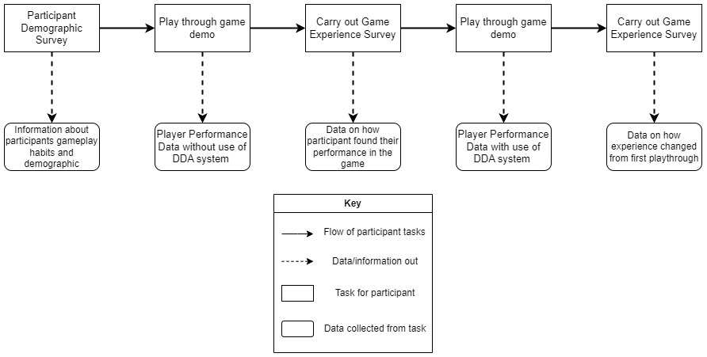

Figure 1

## Investigation

To carry out the study, 10 participants that fit within the required age demographic were gathered, with each participant being asked to meet in person at a scheduled time that the participant agreed upon. All further participant from each individual took place through interactions using the researcher’s personal computer. Once the participants arrived at their respective meeting, each were first given the task of reading the study information sheet and signing the required consent form. Once this was complete, the participants filled out the short online demographic survey to provide initial details of the kind of player they are to influence the later collected data (Appendix 3), before then beginning the first playthrough of the game demo research material. The participants were each instructed to play the game demo either until they felt satisfied that they had taken in the experience enough to comment on it, or until they ran out of lives, ending the game. Each participant approached the game differently, with some users performing significantly better than others and with the play times varying greatly amongst the group.

Originally, the plan for the user study was for the participants to all play the game up to the point that they had lost all of their lives in the game, but certain participants playtime was longer than initially expected due to their higher skill level, and this extended play time would have been unnecessary for the purposes of the study, so the rule was implemented instead that the participant should play the game until they lose all of their lives, or until they were satisfied with their performance and experience in the demo – whichever of these two criteria were met first.

At the end of this first playthrough, the game demo system produced a unique text file containing a range of data about the participants playthrough, including details of how many times the player died in the game, how many enemy characters the player killed, and the total length of the play session in the game. If the participant played until they had ran out of lives in the game, this text file was generated automatically, however as it was predicted that some users may wish to finish their playthrough sooner, the participants could also press the Escape key on the keyboard to generate the data file for their playthrough.

The text files also contain data showcasing how many times the user manually increased or decreased the dynamic difficulty of the game, but during this first playthrough these values always came out to zero, as before the commencement of the first playthrough each participant was instructed not to engage with the dynamic difficulty alteration, therefore no manual increases or decreases occurred for any of the participants, but this data became relevant in the second set of text files generated by the participants at the conclusion of their second playthrough of the game demo. This second set of data text files also includes data showing every time a key was pressed to change the difficulty, and whether the difficulty change was an increase or a decrease as well as the new value of the difficulty level after this change – this data is not present in the first set of data files as the participants did not interact with the difficulty changing controls, therefore the game did not generate this particular data.

Once the participants completed their first playthrough of the game, each carried out their first submission of the online Game Experience Survey (GEQ) (Appendix 4). Here, each participant was requested to respond as candidly as possible to each of the presented statements about the game and their experience whilst engaging with it, with most of the participants completing this first pass of the survey very quickly, and a few others taking longer to consider their responses. No time limit was applied throughout any part of the users’ participation with the study, so participants were free to take as much time as they needed to submit the GEQ. Certain participants completed their submissions of the required surveys exceptionally quickly, possibly suggesting that the responses gathered during their participation may not have been nearly as carefully considered as those of other participants, potentially threatening the reliability of the conclusions able to be drawn from this data.

After the first survey submission was complete, the participants moved on to their second playthrough of the game demo. This time, they were instructed that they were now able to utilise the dynamic difficulty alteration system to any extent that they saw fit, using the O and P keys on the keyboard to decrement and increment the difficulty value respectively. Each participant handled this interaction very differently, with the first participant immediately deciding to increase the difficulty level to the maximum value of 10 and therefore losing their in-game lives extremely quickly, ending their second playthrough exceptionally quickly (Appendix 5.1.2).

The rule established previously in the test, in which a player should finish interacting with the game either if they run out of lives or if they feel that they are satisfied with their performance and experience with the game before the point of running out of lives, was still in place for the participants’ second playthrough of the game, so despite the exceptionally short playthrough of this particular participant, their playthrough came to an end as they ran out of their lives very quickly during the rapid increase of in-game difficulty. Throughout the rest of the participants there was a wide range of approaches to the game now that the participants were able to interact with the DDA system, with any of the players very quickly choosing to rapidly increase the in-game difficulty level and then to continuously increment and decrement the difficulty after this, seemingly experimenting with finding comfortable difficulty levels for their particular style of gameplay.

Once the participants had completed this second playthrough, they then moved on to the second response to the GEQ where, once the participant clarified in the survey that it was their second time responding to it, a new set of questions opened up for them to complete specifically in regard to their experiences and feelings surrounding the second playthrough whilst utilising the dynamic difficulty alteration system. As a whole, players took considerably longer to complete the survey the second time with the second set of questions, implying that participants considered their answers to these questions far more than the first time as they compared their two experiences with the game demo and gave their thoughts about dynamic difficulty adjustment as a whole and the specific implementation utilised within this study. At certain points certain participants required further clarification on the meaning of certain questions, which were promptly provided where required.

Most questions throughout the GEQ required either multiple choice or Likert scale responses, but in the DDA focused set of questions there was also a number of typed-response questions where the participants could leave a longer, more opinionated response if they felt inclined. These longer-form questions were not marked as required in the survey unlike the multiple-choice questions so the participants felt unable to give a productive answer for any reason. Despite this, most of the study participants answered all questions provided and even if some of the participants chose to leave certain text-response questions blank, all participants completed their required surveys appropriately and enthusiastically.

The completion of the participants’ second GEQ submission marked the end of their participation in the study. At this time, all individuals were thanked for their participation and again reassured that no personal data was gathered throughout the study, and if they wished to have the data from their participation in the study removed then they were able to contact the researcher.

## Results

Upon the conclusion of the participant research portion of the project, a range of both quantitative and qualitative data from the participants interaction with the required online surveys and generated automatically by the game demo system at the end of the participants’ playthroughs. The collection of two unique survey responses from each participant – one corresponding to the first playthrough of the game where the participant did not interact with the DDA system and one corresponding to the playthrough in which the user was able to dynamically alter the difficulty – allows for direct comparison on an individual-user basis between the self-perceived user experience whilst playing the game with and without the dynamic difficulty alteration system to therefore draw conclusions on how the use of a DDA alters player experience.

Figure 2

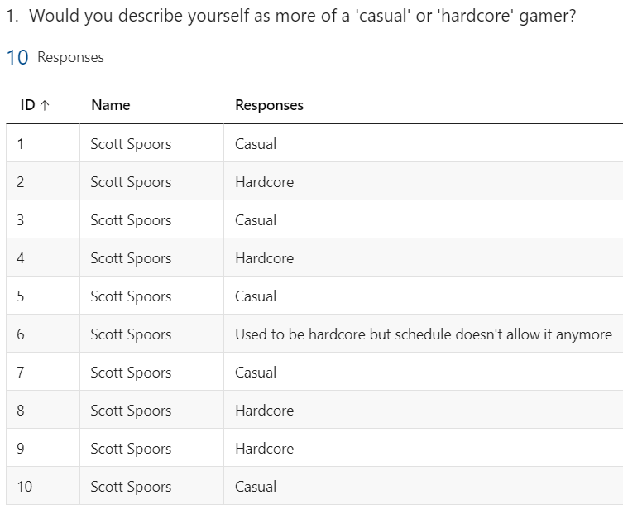Beginning with the Demographic Survey (Appendix 3.2) , there was a relatively even split between the participants over whether they considered themself a ‘casual’ or ‘hardcore’ gamer. Five of the ten participants considered themselves casual players, four of the remaining considered themselves hardcore, and the final participant would have considered themselves a hardcore gamer previously if not for schedule conflicts (Figure 2). For the purposes of this test, the data gathered from the participation of this this particular individual – who will be labelled as Participant 6 – will also be treated as that from a hardcore gamer due to their past experiences with gaming. Going forward in this result analysis, there may be conclusions drawn from the data that are partially derived from the difference in player demographic that may require reference to the participants’ self-described status as casual or hardcore players, so going forward reference to casual players is in reference to Participants 1, 3, 5, 7, and 10, and reference to hardcore players refers to participants 2, 4, 6, 8, and 9 (Figure 3). Please note that all participants are labelled with the name of the researcher as all participation occurred using the researcher’s account to maintain participant anonymity.

Figure 3

Regarding the statistics generated automatically by the game demo at the end of a participants’ playthrough, there is a very clear divide between the in-game performance of the casual and hardcore players in both playthroughs. As expected based on the differences in playstyle between the two subgroups, in both playthroughs the hardcore players successfully defeated a greater number of enemies on average than the casual players, with the average number of enemies defeated by the casual players in the two playthroughs equalling 7.6 and 8.8, and the averages for the hardcore players equalling 27.8 and 16.8 respectively.

Figure 4

Slightly less unexpected however, is the change in trend between the two groups between the first and second playthroughs. As can be seen in Figure 4, casual players killed on average 1.2 enemies more in the second playthrough with the DDA enabled than in the first playthrough, whereas the hardcore players saw a decrease of 9 enemies killed on average from the first playthrough to the second. Whilst this decrease in performance may at first seem like a sign of a worsened user experience, however looking to the responses to the GEQ question asking the participants whether they felt that the dynamic difficulty improved or worsened their experience, all hardcore players commented that the DDA either slightly or greatly improved their experience when interacting with the 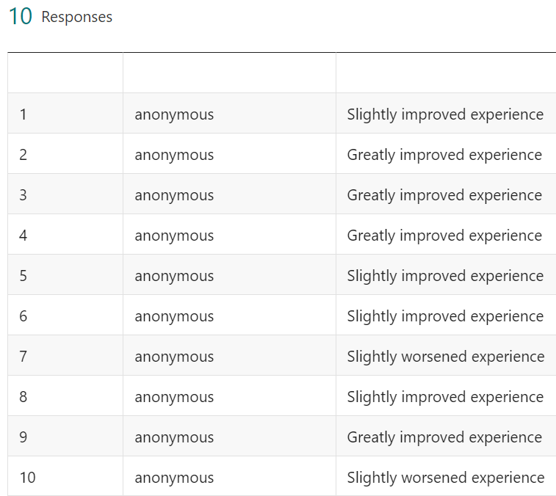game (Figure 5). Reasoning for this can be seen in the answers given to a text-response question in the GEQ where participants were asked to give explanation on how utilising the DDA system altered how they interacted with the game demo as a whole. The responses given to this were varied and a range of conclusions can be inferred from the patterns created in these comments. Despite the decrease in hardcore participant performance, throughout various questions in the GEQ multiple participants – both hardcore and casual – cited the fact that they felt more engaged and appropriately challenged to a level that they felt comfortable, and found the game overall more enjoyable when they were able to alter the difficulty how they saw fit as players were able to test their own performance more with the knowledge that they were always able to decrease it again if they felt overwhelmed, and whilst this led to more frequent deaths for many of the participants, the experience was seemingly overall improved for many of the players.

Figure 5

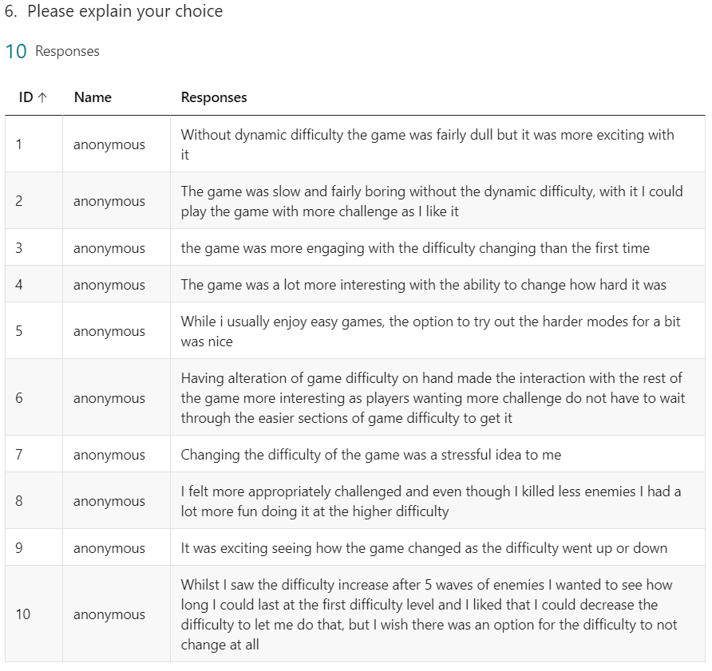There is a consistent pattern amongst both casual and hardcore player responses that the game was noticeably more interesting once they were able to increase the difficulty from the base level, but certain of these responses do not reinforce the hypothesis that dynamic difficulty affects the experience of a user, as this same response could be triggered simply by selecting a higher static difficulty setting at the beginning of a game in a more standard, non-dynamic difficulty system. However, these responses do reinforce a trend that can be seen in many of the other responses throughout the survey – a trend of experimentation.

Figure 6

Throughout both the quantitative and qualitative data collected in the study, there is evidence to support that many of the participants felt more inclined to experimentation when it came to how they approached the game during the second playthrough, particularly in the unique ways in which the players interacted with the dynamic difficulty. The data gathered by Participant 1 shows that this particular player rapidly increased the difficulty to the maximum level and promptly lost all of their in-game lives, ending their second playthrough in under 19 seconds (Appendix 5.1.2); similarly, Participant 10 in their second playthrough continuously decreased the dynamic difficulty level to the lowest point whenever the game would try and increase it at the end of a set of 5 enemy waves (Appendix 5.10.2), these two are unique cases outside of the general behaviour of the players during the second playthrough of the game, but are good examples of the phenomena described by multiple participants that they felt compelled to experiment with new playstyles and tactics, with Participant 5, a casual player who normally only enjoys easy games, commenting on the fact that the option to temporarily increase the difficulty of the game how they saw fit (Appendix 4.2 – Column V, Row 11). This mentality is echoed throughout multiple participants responses to the GEQ and within the automatically generated game statistics, as the casual players at one point or another all increased the dynamic difficulty of the game, and many of these players chose to maintain a higher difficulty level as can be seen in Figure 7, as the average number of difficulty increases for casual players is almost double the number of casual player difficulty decreases, enforcing the idea of experimentation as players seemingly found the higher levels of difficulty more accessible as they knew that this was able to be changed at any time if the higher difficulty became overwhelming.

Figure 7

Within the GEQ, participants were asked whether they had any prior experience with any games that utilised a DDA system. Participants 2, 3, 8, and 10 responded that they had, referencing various on-market games that utilised some form of dynamic difficulty: Mario Kart (Nintendo, 1996) – as previously discussed in Research and Planning – Resident Evil 4 (Capcom, 2005), Half Life 2 (Valve, 2004), and Left 4 Dead (Valve South, 2008). The mention of Mario Kart by Participant 3 comments on the rubber-banding system in the game, commenting “mario kart rubber band driving it was really annoying i hate it”, echoing the findings made prior in this report about this DDA system being significantly too intrusive and generally unfair to players, whereas the comments made toward the three other mentioned games were significantly more positive, praising the games for altering the difficulty based on player behaviour and for the subtlety of these changes, clearly describing how these specific implementations of DDA systems greatly improved the players’ experiences with these particular games.

DDA systems currently utilised in games generally apply some form of automation in controlling the difficulty level of the game, generally based around various metrics of player performance in the game. The participants were asked whether they would have preferred this approach or the manual control offered by the game demo in this project (Figure 8), and five of the nine responders decided they preferred the manual control method, with a pattern developing among the participants who preferred this commenting that if this manual control of difficulty was taken away from them they would find this ‘frustrating’ or feel like the game was ‘cheating’. It is worth noting however, that the participants who had previously reported that they had prior positive experience with a game with an integrated DDA system all responded that they would prefer a fully automated form of difficulty adjustment, with Participants 4 and 10 both bringing up an interesting point that players – if given complete manual control over subtle dynamic difficulty adjustment – would continuously exploit this ability and over-utilise the system to the point of it starting to detract from the overall experience of the game itself. On the other hand, certain responses in favour of the manual control variant of the DDA system may in fact suggest that the use of a manually controlled dynamic difficulty adjustment system may be a more accessible option, as certain players may find it alienating or frustrating if the game automatically made the experience more difficult for them without providing any explicit way to undo this action.

Figure 8

Overall, the results gathered within the text files automatically generated by the game demo at the end of participants’ playthrough proved to be quite representative of the self-identified demographics of the individuals that took part in the study. To showcase this, this next section will focus on the performance of one participant from each sub-demographic, Participant 5 – a casual player, and Participant 8 – a hardcore player.

Participant 5 entered the study considering themself as a casual player, being very inexperienced in playing difficult video games and only playing games once or twice a month, whereas Participant 8 considered themself a hardcore player, with large levels of experience playing difficult games and playing video games every day (Appendix 3.1).

Figure 9

The results collected in their first game demo playthrough data reflect this self-identification clearly (Figure 9). Both participants died the same number of ten times, with Participant 5 killing 6 enemies before the end of the game and Participant 8 killing 32. Both participants’ second playthroughs were significantly shorter than their first, with Participant 5’s second playthrough ending in 5 minutes and 53 seconds – 68 seconds shorter than the first playthrough (Appendix 5.5), and Participant 8’s second playthrough ending in 6 minutes and 27 seconds – 10 minutes and 12 seconds shorter than the first playthrough (Appendix 5.8). During the second playthrough, the performances of the participants were significantly more comparable, with a difference of only 6 enemies killed between the two, and Participant 8 having two more deaths than Participant 5. Both participants agreed that the experience of the game was slightly improved with the inclusion of the interaction with the DDA, with both participants echoing the ideas of experimentation and the ability to cater the game to their individual requirements (Appendix 3.1). The fact that two players of such drastically different playstyles and gaming preferences both agree that the interaction with the DDA system provided for an overall improved experience with the game clearly highlights how the use of a DDA can improve the chances of a particular video game being more widely accessible to a varied range of audiences and player types.

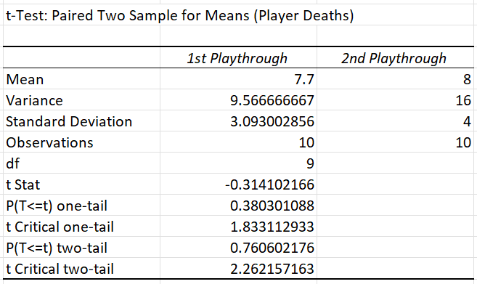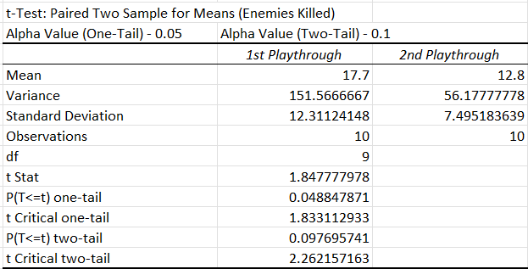A paired-sample t-test was performed on the range of data generated from the participants interactions with the game demo in order to determine whether the interaction with the DDA had any statistical significance in changing the experience of the participants. An alpha significance value of 0.05 was used, with the null hypothesis being that there is not enough evidence to suggest that the DDA has any significant effect on player engagement and experience, and the alternate hypothesis being that the DDA system does result in a significant difference to the player engagement and experience. The paired sample t-test was used to compare statistics gathered from the two playthroughs of the game demo from each participant and compares the calculated p-value of the analysed data with the appropriate alpha significance value to determine whether the null hypothesis can be rejected. Paired sample t-tests were performed on both the data of enemies killed and player lives lost for all players, as well as isolated tests on the same data specifically for casual or hardcore players to see if the difference in demographic performance made any difference to the conclusions that could be drawn. Looking to the statistics drawn from the Enemies Killed for all players (Figure 10), p-values of approximately 0.049 and 0.098 were gathered for one-tail and two-tail, both below their respective alpha values, suggesting that overall in terms of how participants defeated enemies, the DDA system did have a significant effect. This fact does not stand for the number of player deaths (Figure 11), so calculations were also done on the metrics gathered by the hardcore and casual participants separately in order to see if there was any noteworthy differences in these datapoints.

Figure 11

Figure 10

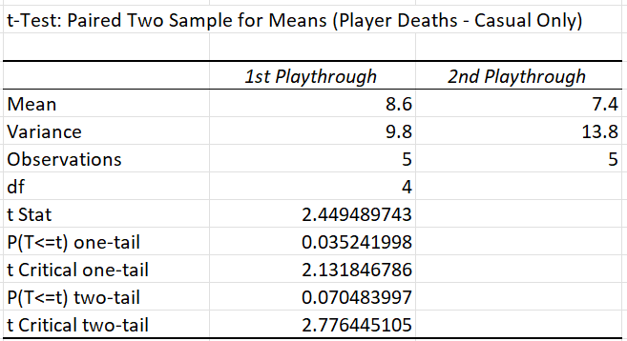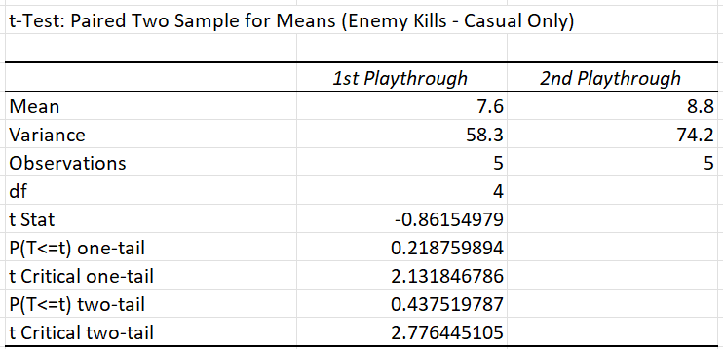Looking to the findings specifically focused on the Casual Players, it can be observed that there is not enough evidence within the data focused on enemy kills (Figure 12) to support the alternate hypothesis, but unlike the statistics gathered from the overall group, there is clear evidence within the casual player death statistics to support the idea that the DDA had an impact on casual player experience as both calculated p-values are significantly below the alpha significance values(Figure 13).

Figure 12

As for the hardcore players, the data gathered from these participants mirrors that of the casual players. The data gathered around the hardcore players’ in-game death (Figure 14) show an extreme lack of evidence to support the dismissal of the null hypothesis, whereas the p-values gathered from the comparison of hardcore enemy kills (Figure 15) show extremely high levels of evidence that the DDA had a significant impact on the average in-game experience of the hardcore participants.

Figure 13

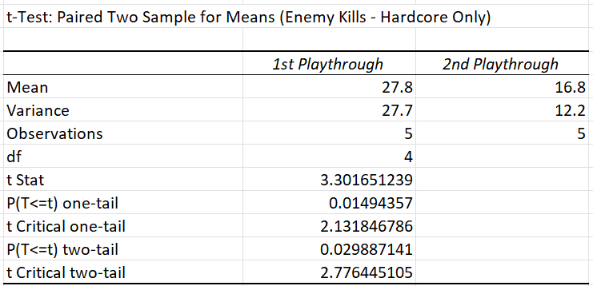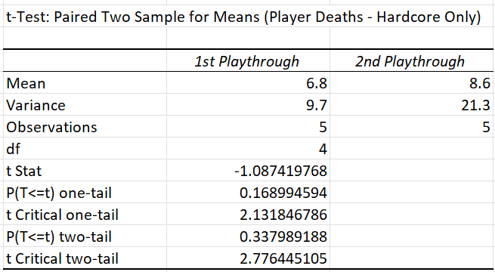Whilst this contrasting data between the two demographics of participants may seem contradictory and therefore invalidating of any conclusions that could be drawn from the data, it can be seen that in all three groups – casual, hardcore, and all participants – at least one of the paired sample t-tests provided evidence that the interaction with the DDA system provided a noticeable difference to player experience within the game demo, and the differences in where this evidence came from between the groups and how strong that evidence was implies that for different demographics or playstyles the player experience will be affected in different ways.

Figure 15

Figure 14

# Evaluation

## Evaluation of Findings

Throughout the participant research portion of this study, a range of quantitative and qualitative data was gathered throughout participant interaction with both the game demo and its integrated DDA system, and the required demographic survey and Game Experience Questionnaire. After performing thematic analysis on various responses gathered from the GEQ, as well as performing various forms of inferential statistical analysis on this data and the data automatically generated by the game demo system at the end of each participant playthrough, a large range of results were collected that provide various answers to the question of how player experience and video game accessibility is altered by the use of a DDA system. Largely, the results gathered from the investigation support the fact that the interaction with the DDA had a significant effect on the user experience of the participants involved in the study, and collating the statistical results of the participant gameplay data and the thematic results of the survey responses, it can be seen that overall the effect of the DDA system on the users’ experience with the game was primarily a positive one.

A major drawback to the reliability of the results gathered from this investigation however is simply due to the small sample size of participants gathered for the study. By the end of the participant investigation, 10 individuals had taken part in the study, working out with five participants representing ‘hardcore’ players and five representing ‘casual’ players. Due to the relatively tight schedule required during the development of this project, particularly in order to carry out the participant study within the required time scale, this small sample size was planned from the beginning of the planning phase and was overall totally suitable for the requirements of this investigation, however the reliability and generalisability of the gathered results would have been greatly improved if a larger sample group would have been possible in carrying out the study.

The gathered results however still show some clear evidence of significant improvements to certain players’ experiences with the game demo through interaction with the DDA. For instance, focusing on the results gathered from the paired sample t-test of the ‘hardcore’ players (Figure 14, Figure 15), and relating this statistical data to the GEQ survey responses from the same subset of participants (Figure 5, Figure 6), it can be seen firstly that there is statistically significant evidence to prove that interaction with the DDA system had a notable effect on the experience of the ‘hardcore’ players, and that this effect on the user experience was overall a definite positive change due to the responses given to the experience survey by the same group of participants.

This is despite the fact that, as can be seen in Figure 4, the ‘hardcore’ players on average defeated significantly less enemies in the game during the second playthrough than in their first playthrough. This would therefore generally suggest a worsened experience in the game, however the GEQ responses from these participants show instead that they felt more appropriately challenged and more prone to experimentation in their second playthrough. Therefore – through the use of both the statistical data gathered from in-game player performance and the qualitative GEQ survey responses – it can be concluded that for the ‘hardcore’ participants the interaction with the dynamic difficulty adjustment system provided a noticeably better, more challenging, more enjoyable experience than when the players were playing the game without interacting with the DDA.

Looking to the findings from the data gathered from the ‘casual’ participants showcases a slightly different set of conclusions than those drawn up from the ‘hardcore’ players. The same style of paired value t-tests were carried out on the casual player data gathered from the participant playthroughs, and these tests produced a somewhat mirrored set of results to those produced in the hardcore tests. Here, the datapoint that shows a statistical significant change as a result of the interaction with the DDA is the ‘player death’ statistic, rather than the ‘enemies killed’ statistic like the hardcore data.

As can be seen in Figures 12 and 13 also, the results gathered – whilst still statistically significant enough to validate the fact that the DDA interaction impacted the experience of the players – is notably less statistically significant than the results gathered from the same tests on the exclusively hardcore data. This suggests that whilst the DDA did affect the player experience of the casual players, and that this alteration of player experience was overall a positive change for casual players as can be seen in Figure 5, the level of impact on the player experience of the casual players was noticeably lower than that of the hardcore players.

This statistic is also notably less reliable than the result gathered from the ‘enemies killed’ data from the hardcore players, as the reason for a different number of player deaths between the two playthroughs in certain participants’ circumstances may not have been due to differing levels of challenge or differences of gameplay experience, but simply due to the fact of the player choosing to end their playthrough sooner. During the investigation, participants were encouraged to play through the game until its completion – meaning that they had depleted all of their in-game lives – but for the sake of participant comfort and accessibility they were also informed that they were able to end the playthrough sooner if they felt that they were satisfied with their interaction with the game and their performance therein. Whilst this was both necessary for participant comfort and accessibility during the investigation, and for the purposes of not making certain players’ participation drag on for unnecessarily long, the fact that players were able to end their playthroughs of the game whenever they saw fit definitely harmed the reliability of certain elements of the gathered data.

In order to further solidify the reliability and validity of the data also, it would be beneficial to get each participant to play through the game in both of its states – without interacting with the DDA system and with this interaction – multiple times each to be able to calculate a set of average performance data for each user in both stages, greatly increasing the reliability of each participants’ data as being a reliable representation of their standard gameplay performance as well as increasing reliability of the conclusions surrounding the level of impact that the DDA system interaction had on each players’ experience with the game.

The findings of this investigation greatly reflect those gathered by Horne (2018) in their study comparing the differences of effect on gameplay experience of an automated DDA system compared a live ‘Wizard of Oz’ individual manually adjusting the gameplay dynamics. This investigation found that the differences between these two forms of gameplay alteration in terms of changes to player experience were negligible, but – importantly for this study – found that there was a statistically significant improvement to player engagement with the game whilst the DDA system was in play, a conclusion which the results of this investigation greatly echo.

## Evaluation of Project Process

Overall, the course of development of this project has progressed fairly smoothly and primarily followed the original plan laid out for it in the initial planning stages. There were many changes made to certain areas of the content of the project throughout this course of development that allowed for more streamlined development or generally came to make significantly more sense within the flow of the project than the ideas that were proposed within the original objective proposal in the Terms of Reference documentation (Appendix 1).

For instance, early on in the development cycle of the project, it was planned that this project would focus on the development of a game demo with integrated DDA system as a standalone product, with extensive documentation on the development cycle of the code for this product as well as production of testing documentation to showcase the testing of all functional elements of the game demo product. However, it was agreed early on in the production of the project deliverables that instead this project would make significantly more sense as a research focused project, rather than being focused on purely functional product development. To aid this, focus was removed from certain original objectives – such as the production of testing documentation – to instead provide a greater focus on producing the game demo as a form of research material, alongside a range of other research materials to be used to study the affects of a DDA system on the gameplay experience of a range of participants.

Whilst the development of the project and the results gathered from it overall were definitely satisfactory to the original vision of the project, there were a number of aspects that should be changed for comparable projects in the future. For instance, organisation of workflow and sticking to a stringent schedule should be more prioritised than was possible during certain areas of this projects development. The overall flow of the project development followed the plan laid out in the Terms of Reference and Gantt Chart, but due to the altered project focus as compared to the original plan, and due to the altered workflow that this required, the original project schedule ended up becoming fairly altered from that original project flow.

Despite this however, the work that was completed for the purposes of this project was completed consistently within the allotted suggested timeframes. At the beginning of the project after the original project idea was approved, immediately work began on piecing together a diverse list of academic research papers to be used for the Literature Review portion of the project report as well as to be referenced for inspiration throughout any other relevant portions of the project report or throughout any other relevant area of project development. After gathering and reading through a range of academic sources, the development of the Research and Planning section of this report began promptly and was completed within the allotted time as originally intended, and the production of the game demo research material and integrated dynamic difficulty adjustment system progressed significantly more smoothly than originally feared.

Additionally, with the idea switching to a more research/participant investigation style project relatively early on, more studying should have been carried out in these early stages of research and planning into various research methodologies that could have been utilised and adapted within the investigation portion of this project.

Originally, a more traditional, fully automated dynamic difficulty adjustment system was planned for inclusion in this project, however it was realised early on in development that this automated system would have taken significantly too much time to develop, meaning the participant investigation would have needed to be significantly more rushed or may not have been possible within the remaining time after the completion of code development. Additionally, inspiration was taken from the ‘Wizard of Oz’ DDA experiment (Horne, 2018), in which part of the participant investigation utilised another individual hidden from the participants’ view who was in charge of altering the difficulty in the game that the participant was playing. This inspired the thought that throughout the Research and Planning portion of this project, there had not been any encountered instances of research carried out on how the user experience within a game that utilises a DDA system may be affected if the participant themselves are given full manual control over this system. This fact was a large motivator for developing the game demo research material and DDA in the form that it turned out, and the use of this fully manual system in the participant investigation provided a unique and interesting set of results for analysis that allowed for a range of satisfactory conclusions into the original question of this study of how the interaction with a DDA system in a game can affect player experience and accessibility of a game.

Ideally, experimental ideas discussed in the Research and Planning section of the project report, such as utilisation of experimental keyboard dynamic tracking to control the alteration of the dynamic difficulty system, would have been integrated into the game demo research material, but within the required timeframe this sort of advanced experimental subsystem would not have been viable, and given the constraints the system produced and the results gathered from this were more than satisfactory from the original vision of the project.

# Conclusions and Recommendations

This project aimed to study how interaction with an integrated Dynamic Difficulty Adjustment system alters the accessibility and player experience of a video game for individuals aged between 20 and 30. To achieve this goal, firstly a review of currently published academic literature from the field of study surrounding DDA systems in gaming – as well as into various other fields of computing research that may have provided relevant findings, systems, and theories – was carried out. The results of this review then formed the basis of a research methodology for a participant investigation with individuals of the target demographic, as well as a development plan for a set of appropriate research materials to be used within this investigation. This included a short, arcade-style video game demo with an integrated DDA system, and multiple online surveys for the participants to fill out at different times during their investigation participation to gather a range of quantitative and qualitative data on the participant’s in-game performance as well as their personal feelings toward the game demo and the integrated DDA. All of the data gathered from the participant investigation was analysed using a range of methods including thematic analysis of player-opinion/emotion based responses, and inferential statistics carried out on the player performance data generated by the game demo, with all of this analysed data being brought together in order to draw a series of conclusions around the original question of the project.

The results drawn from the various analysed results of the investigation all point to the conclusion that interaction with a DDA system has a significant and clearly noticeable effect on the engagement of players with a video game, with many of the results pointing to the fact that largely this interaction with the DDA system resulted in a noticeably improved player experience in the game demo. The participants that took part in the project investigation were separated into two distinct categories for the purposes of certain areas of the result analysis: ‘casual’ – players who had less experience playing difficult games or generally played games less seriously/less frequently, and ‘hardcore’ – players who had noticeably more experience in playing difficult games or generally spent larger amounts of times playing games/played games more seriously than the other participants.

Breaking the participants into these categories proved essential in the analysis of the participant investigation data, which showed the effect on player experience of interaction with the DDA system was significantly different between these two groups, with the alteration of player experience for the hardcore participants being extremely positive on average – with the change to the player experience of this group also being noticeably more statistically significant than that of the casual players. It is also worth noting that whilst all participants agreed that there was a definite alteration to their experience with the game, the only participants that commented that the DDA system worsened their experience with the game came from the casual player group of participants, where some participants found the idea of a dynamic difficulty system to be stressful or generally preferred the difficulty to remain static. Contrary to this, the results and responses from other participants in this same group suggested that interaction with the DDA system gave them a feeling of increased freedom to experiment with the higher difficulty options in the game, potentially increasing the accessibility of the game for these players. The combination of these conclusions suggest that for many players the inclusion of a dynamic difficulty alteration system in a video game would provide a noticeably improved user experience and potentially increased gameplay accessibility for certain users, however this form of DDA system if possible should be an optional system that players can opt out of if they so choose as for certain players this dynamically altering difficulty level may become quickly daunting and ultimately hinder the gameplay experience.

If future work were to be done in this field, various new forms of automation and player customisation should be pursued. Fields of study such as keystroke dynamics could be utilised alongside machine learning techniques and more typical in-game automated player behaviour tracking in order to create robust forms of automation of DDA systems, but also forms of manual DDA alteration may be explored further past the work of this project to further determine the feasibility of a manual DDA system in a commercial game. Player customisability should be prioritised throughout all of this with any implementation of DDA systems however in order to provide the most accessible experience within video games for as many styles and demographics of players as possible.

# Reference List

1. Ali, M.L., Monaco, J.V., Tappert, C.C. and Qiu, M. (2017) 'Keystroke biometric systems for user authentication' Journal of Signal Processing Systems, 86(2), pp.175-190. Available at: <https://link.springer.com/article/10.1007/s11265-016-1114-9>
2. Baldwin, A., Johnson, D. and Wyeth, P.A. (2014) 'The effect of multiplayer dynamic difficulty adjustment on the player experience of video games' CHI'14 Extended Abstracts on Human Factors in Computing Systems (pp. 1489-1494). Available at: <https://dl.acm.org/doi/abs/10.1145/2559206.2581285?casa_token=S5DXpKe81YIAAAAA:87K9SliWa0IA-v9JgNEA-buD6gJBwMTFEpKy3b_BkPqi3nDTf-LzY14BwBOsFRDvZxFB4WIxbDoG5g>
3. Baum, L. F. (1900) ‘The Wonderful Wizard of Oz’ *George M. Hill Company*
4. Bizarre Creations. (2005) *Geometry Wars: Retro Evolved* [Video Game]. Microsoft Game Studios.
5. Capcom Production Studio 4 (2005) *Resident Evil 4* [Video Game]. Capcom.
6. Constant, T. and Levieux, G. (2019) 'Dynamic difficulty adjustment impact on players' confidence.' Proceedings of the 2019 CHI conference on human factors in computing systems (pp. 1-12). Available at: <https://dl.acm.org/doi/abs/10.1145/3290605.3300693?casa_token=-sag2nkmBEMAAAAA:rdy-Gg8-J3D4z6LDKB7s2tQ_NRhfGXolZBvN37A8K72l_3MpBVKyOpBq7tFz5RrQ2-KDW8ZHn_ry6w>
7. Epic Games (2007) *Unreal Tournament 3* [Video Game]. Midway Games
8. Epic Games. (2020) *Unreal Engine 4* (Version 4.26) [Computer Program]. Available at: <https://www.unrealengine.com/en-US/download>
9. Horne, S.T. (2018) 'Dynamic difficulty adjustment: using the Wizard of Oz method to investigate potential improvements through biofeedback' Doctoral dissertation, Laurentian University of Sudbury. Available at: <https://zone.biblio.laurentian.ca/handle/10219/3391>
10. Hunicke, R. (2005) 'The case for dynamic difficulty adjustment in games' Proceedings of the 2005 ACM SIGCHI International Conference on Advances in computer entertainment technology (pp. 429-433). Available at: <https://dl.acm.org/doi/abs/10.1145/1178477.1178573?casa_token=R6Ods4RqhJYAAAAA:hlAS0W_GHjAp_Gl2vuPyvjIeWRczbNhXWo2x6pqP7ykDmeQjhm_4VSdpF8HTsS_bpxJ3yHWHpccdPQ>
11. Hunicke, R., Leblanc, M. & Zubek, R. (2004). 'MDA: A Formal Approach to Game Design and Game Research.' Proceedings of the AAAI Workshop on Challenges in Game AI (Vol. 4, No. 1, p. 1722). Available at: <http://courses.washington.edu/css385/2017.Spring/Readings/MDA.pdf>
12. IJsselsteijn, WA, de Kort, YAW & Poels, K. (2013) 'The Game Experience Questionnaire'. *Technische Universiteit Eindhoven, Eindhoven*. Available at: <https://research.tue.nl/en/publications/the-game-experience-questionnaire>
13. Law, E.L.C., Brühlmann, F. and Mekler, E.D. (2018) 'Systematic review and validation of the game experience questionnaire (geq)-implications for citation and reporting practice'. *Proceedings of the 2018 Annual Symposium on Computer-Human Interaction in Play (pp. 257-270)*. Available at: <https://dl.acm.org/doi/abs/10.1145/3242671.3242683>
14. Lim, Y.M., Ayesh, A. and Stacey, M. (2014) 'Detecting cognitive stress from keyboard and mouse dynamics during mental arithmetic' *2014 Science and Information Conference (pp. 146-152). IEEE*. Available at: <https://ieeexplore.ieee.org/abstract/document/6918183>
15. Liu, C., Agrawal, P., Sarkar, N. and Chen, S. (2009) 'Dynamic difficulty adjustment in computer games through real-time anxiety-based affective feedback.' International Journal of Human-Computer Interaction, 25(6), pp.506-529. Available at: <https://www.tandfonline.com/doi/abs/10.1080/10447310902963944>
16. Maxion, R.A. and Killourhy, K.S. (2010) 'Keystroke biometrics with number-pad input' *2010 IEEE/IFIP International Conference on Dependable Systems & Networks (DSN) (pp. 201-210). IEEE*. Available at: <https://ieeexplore.ieee.org/abstract/document/5544311?casa_token=WTie4AmLuKkAAAAA:e4nE42mJ9jL4JFctfgoN0Iv8qLfcz8EZq0pjPMjlvi0Blqso7nFi5RldaeFLuaJw2FbK8fuI0A>
17. Melder, N. (2013) 'A rubber-banding system for gameplay race management' *Game AI Pro.* Available at: <http://www.gameaipro.com/GameAIPro/GameAIPro_Chapter42_A_Rubber-Banding_System_for_Gameplay_and_Race_Management.pdf>
18. Monrose, F. and Rubin, A.D. (2000) 'Keystroke dynamics as a biometric for authentication' *Future Generation computer systems, 16(4), pp.351-359*. Available at: <https://www.sciencedirect.com/science/article/pii/S0167739X9900059X?casa_token=qORaJnQRm88AAAAA:uccfLQ-aX6Pjdf3b6y5LZm3bFQaNOOh4tsKmIVSIRipD_1BJtetnhI7iR_1yWjppH7kN1l-eSGg>
19. Moirn, R., Léger, P.M., Senecal, S., Bastarache-Roberge, M.C., Lefèbrve, M. and Fredette, M. (2016) 'The Effect of Game Tutorial: A comparison between casual and hardcore gamers' *Proceedings of the 2016 Annual Symposium on Computer-Human Interaction in Play companion extended abstracts (pp. 229-237)*. Available at: <https://dl.acm.org/doi/abs/10.1145/2968120.2987730?casa_token=aTqHUB98DfgAAAAA:5QRZy8D2CLGYCA1hr8MIxT4Z_PAtgOCorwd9VJAIDzjSCt-yzDSGV4fw1wMvrH6BWGpOxkuIB5WmAg>
20. Newcastle University. (2016) ‘AI Tutorial 3: AI in Games Development’.
21. Nintendo EAD (1996) *Mario Kart 64* [Video Game]. Nintendo.
22. Nintendo EAD. (2014) 'Mario Kart 8' *Nintendo*
23. Pepa, L., Sabatelli, A., Ciabattoni, L., Monteriù, A., Lamberti, F. and Morra, L. (2020) 'Stress detection in computer users from keyboard and mouse dynamics' *IEEE Transactions on Consumer Electronics, 67(1), pp.12-19*. Available at: <https://ieeexplore.ieee.org/abstract/document/9296377>
24. Plant, R.W. and Ryan, R.M. (1985) 'Intrinsic motivation and the effects of self‐consciousness, self‐awareness, and ego‐involvement: An investigation of internally controlling styles'. *Journal of personality, 53(3), pp.435-449*. Available at: <https://selfdeterminationtheory.org/wp-content/uploads/2014/04/1985_PlantRyan.pdf>
25. Poels, Y., Annema, J.H., Verstraete, M., Zaman, B. and De Grooff, D. (2012) 'Are you a gamer? A qualititive study on the parameters for categorizing casual and hardcore gamers' *Iadis International Journal on www/internet, (1), pp.1-16*. Available at: <https://lirias.kuleuven.be/1859869?limo=0>
26. Ravaja, N., Turpeinen, M., Saari, T., Puttonen, S. and Keltikangas-Järvinen, L. (2008) 'The psychophysiology of James Bond: Phasic emotional responses to violent video game events' *Emotion, 8(1), p.114.* Available at: <https://psycnet.apa.org/doiLanding?doi=10.1037%2F1528-3542.8.1.114>
27. Rodriguez, G.R. (2019) 'Player Modeling for Dynamic Difficulty Adjustment in Top Down Action Games' Northeastern University. Available at: <https://www.proquest.com/docview/2384839459?pq-origsite=gscholar&fromopenview=true>
28. Romera, G R. (2019) 'Player Modeling for Dynamic Difficulty Adjustment in Top Down Action Games', Northeastern University. Available at: <https://www.proquest.com/docview/2384839459?pq-origsite=gscholar&fromopenview=true>
29. Scott, M.J. and Ghinea, G. (2013) ‘Promoting game accessibility: Experiencing an induction on inclusive design practice at the global games jam’ *arXiv preprint arXiv:1305.4359*. Available at: <https://arxiv.org/abs/1305.4359>
30. Segundo, C.V., Emerson, K., Calixto, A. and Gusmao, R.P. (2016) ‘Dynamic difficulty adjustment through parameter manipulation for Space Shooter game’ *Proceedings of SB Games*. Available at: <https://www.researchgate.net/profile/Caetano-Segundo/publication/327920069_Dynamic_difficulty_adjustment_through_parameter_manipulation_for_Space_Shooter_game/links/5cdb3363a6fdccc9ddae3b5a/Dynamic-difficulty-adjustment-through-parameter-manipulation-for-Space-Shooter-game.pdf>
31. Thornton, M.A. (2019) 'Keyboard dynamics' *Encyclopedia of Cryptography, Security and Privacy, pp.1-6.* Available at: <https://link.springer.com/referenceworkentry/10.1007/978-3-642-27739-9_783-2>
32. Topala, R. (2013) ‘Geometry Dash’ *RobTop Games*
33. Unity Technologies. (2022) *Unity* (Version 2022.1.13) [Computer Program]. Available at: <https://unity.com/download>
34. Valve (2004) *Half Life 2* [Video Game]. Valve.
35. Valve South (2008) *Left 4 Dead* [Video Game]. Valve.
36. Vid Kidz. (1982) *Robotron: 2084* [Video Game]. Williams Electronics.
37. Vizer, L.M. (2009) 'Detecting cognitive and physical stress through typing behavior' *CHI'09 Extended Abstracts on Human Factors in Computing Systems (pp. 3113-3116)*. Available at: <https://dl.acm.org/doi/abs/10.1145/1520340.1520440?casa_token=D-qZKGyGKp8AAAAA:m_CgWJ8agz6uTQ_6JdyG_haxi198H0cOXgYdUuHibJThG4qUqWHpCh1TMifnXB1Pp-zpFX411QC01g>
38. Xue, S., Wu, M., Kolen, J., Aghdaie, N. and Zaman, K.A. (2017) 'Dynamic difficulty adjustment for maximized engagement in digital games.' Proceedings of the 26th International Conference on World Wide Web Companion (pp. 465-471). Available at: <https://dl.acm.org/doi/abs/10.1145/3041021.3054170?casa_token=5OuuxXpGt4QAAAAA:lKKQKXtF5aOLM7EHAeK4gj8-CrrKP_9qdtBEbrer6YaNdVDjrCKf7-dqS0ChixICZ_lyjypnGoPyzQ>
39. YoYo Games. (2022) *GameMaker* (Version 2022.11) [Computer Program] Available at: <https://gamemaker.io/en/download>
40. Zohaib, M. (2018) 'Dynamic difficulty adjustment (DDA) in computer games: A review.' Advances in Human-Computer Interaction, 2018. Available at: <https://www.hindawi.com/journals/ahci/2018/5681652/>
41. Zook, A. and Riedl, M. (2021) 'A temporal data-driven player model for Dynamic Difficulty Adjustment', Proceedings of the AAAI Conference on Artificial Intelligence and Interactive Digital Entertainment, 8(1), pp. 93–98. Available at: <https://doi.org/10.1609/aiide.v8i1.12504>.

# Bibliography

1. Ali, M.L., Monaco, J.V., Tappert, C.C. and Qiu, M. (2017) 'Keystroke biometric systems for user authentication' Journal of Signal Processing Systems, 86(2), pp.175-190. Available at: <https://link.springer.com/article/10.1007/s11265-016-1114-9>
2. Aponte, M.V., Levieux, G. and Natkin, S. (2009) 'Scaling the level of difficulty in single player video games' International Conference on Entertainment Computing (pp. 24-35). Springer, Berlin, Heidelberg. Available at: <https://link.springer.com/chapter/10.1007/978-3-642-04052-8_3>
3. Baldwin, A., Johnson, D. and Wyeth, P.A. (2014) 'The effect of multiplayer dynamic difficulty adjustment on the player experience of video games' CHI'14 Extended Abstracts on Human Factors in Computing Systems (pp. 1489-1494). Available at: <https://dl.acm.org/doi/abs/10.1145/2559206.2581285?casa_token=S5DXpKe81YIAAAAA:87K9SliWa0IA-v9JgNEA-buD6gJBwMTFEpKy3b_BkPqi3nDTf-LzY14BwBOsFRDvZxFB4WIxbDoG5g>
4. Baum, L. F. (1900) ‘The Wonderful Wizard of Oz’ *George M. Hill Company*
5. Bizarre Creations. (2005) *Geometry Wars: Retro Evolved* [Video Game]. Microsoft Game Studios.
6. Burke, A. (2012) 'Using Player Profiling to Enhance Dynamic Difficulty Adjustment in Video Games'. Available at: <https://digitalcommons.calpoly.edu/cpesp/76/>
7. Capcom Production Studio 4 (2005) *Resident Evil 4* [Video Game]. Capcom.
8. Charleer, S., Gutiérrez, F., Gerling, K. and Verbert, K. (2018) 'Towards an open standard for gameplay metrics' Proceedings of the 2018 Annual Symposium on Computer-Human Interaction in Play Companion Extended Abstracts (pp. 399-406). Available at: <https://dl.acm.org/doi/abs/10.1145/3270316.3271529>
9. Constant, T. and Levieux, G. (2019) 'Dynamic difficulty adjustment impact on players' confidence.' Proceedings of the 2019 CHI conference on human factors in computing systems (pp. 1-12). Available at: <https://dl.acm.org/doi/abs/10.1145/3290605.3300693?casa_token=-sag2nkmBEMAAAAA:rdy-Gg8-J3D4z6LDKB7s2tQ_NRhfGXolZBvN37A8K72l_3MpBVKyOpBq7tFz5RrQ2-KDW8ZHn_ry6w>
10. Epic Games (2007) *Unreal Tournament 3* [Video Game]. Midway Games
11. Epic Games. (2020) *Unreal Engine 4* (Version 4.26) [Computer Program]. Available at: <https://www.unrealengine.com/en-US/download>
12. Horne, S.T. (2018) 'Dynamic difficulty adjustment: using the Wizard of Oz method to investigate potential improvements through biofeedback' Doctoral dissertation, Laurentian University of Sudbury. Available at: <https://zone.biblio.laurentian.ca/handle/10219/3391>
13. Hunicke, R. (2005) 'The case for dynamic difficulty adjustment in games' Proceedings of the 2005 ACM SIGCHI International Conference on Advances in computer entertainment technology (pp. 429-433). Available at: <https://dl.acm.org/doi/abs/10.1145/1178477.1178573?casa_token=R6Ods4RqhJYAAAAA:hlAS0W_GHjAp_Gl2vuPyvjIeWRczbNhXWo2x6pqP7ykDmeQjhm_4VSdpF8HTsS_bpxJ3yHWHpccdPQ>
14. Hunicke, R., Leblanc, M. & Zubek, R. (2004). 'MDA: A Formal Approach to Game Design and Game Research.' Proceedings of the AAAI Workshop on Challenges in Game AI (Vol. 4, No. 1, p. 1722). Available at: <http://courses.washington.edu/css385/2017.Spring/Readings/MDA.pdf>
15. IJsselsteijn, WA, de Kort, YAW & Poels, K. (2013) 'The Game Experience Questionnaire'. *Technische Universiteit Eindhoven, Eindhoven*. Available at: <https://research.tue.nl/en/publications/the-game-experience-questionnaire>
16. Law, E.L.C., Brühlmann, F. and Mekler, E.D. (2018) 'Systematic review and validation of the game experience questionnaire (geq)-implications for citation and reporting practice'. *Proceedings of the 2018 Annual Symposium on Computer-Human Interaction in Play (pp. 257-270)*. Available at: <https://dl.acm.org/doi/abs/10.1145/3242671.3242683>
17. Lenzini, A. (2022) ‘Resident Evil 4's Most Important Feature Is One Players May Have Missed’. Available at: <https://www.cbr.com/resident-evil-4-dynamic-difficulty-capcom/>
18. Lim, Y.M., Ayesh, A. and Stacey, M. (2014) 'Detecting cognitive stress from keyboard and mouse dynamics during mental arithmetic' *2014 Science and Information Conference (pp. 146-152). IEEE*. Available at: <https://ieeexplore.ieee.org/abstract/document/6918183>
19. Liu, C., Agrawal, P., Sarkar, N. and Chen, S. (2009) 'Dynamic difficulty adjustment in computer games through real-time anxiety-based affective feedback.' International Journal of Human-Computer Interaction, 25(6), pp.506-529. Available at: <https://www.tandfonline.com/doi/abs/10.1080/10447310902963944>
20. Maxion, R.A. and Killourhy, K.S. (2010) 'Keystroke biometrics with number-pad input' *2010 IEEE/IFIP International Conference on Dependable Systems & Networks (DSN) (pp. 201-210). IEEE*. Available at: <https://ieeexplore.ieee.org/abstract/document/5544311?casa_token=WTie4AmLuKkAAAAA:e4nE42mJ9jL4JFctfgoN0Iv8qLfcz8EZq0pjPMjlvi0Blqso7nFi5RldaeFLuaJw2FbK8fuI0A>
21. Melder, N. (2013) 'A rubber-banding system for gameplay race management' *Game AI Pro.* Available at: <http://www.gameaipro.com/GameAIPro/GameAIPro_Chapter42_A_Rubber-Banding_System_for_Gameplay_and_Race_Management.pdf>
22. Missura, O. (2015) 'Dynamic Difficulty Adjustment', Doctoral dissertation, Universitäts-und Landesbibliothek Bonn. Available at: <https://hdl.handle.net/20.500.11811/6543>
23. Moirn, R., Léger, P.M., Senecal, S., Bastarache-Roberge, M.C., Lefèbrve, M. and Fredette, M. (2016) 'The Effect of Game Tutorial: A comparison between casual and hardcore gamers' *Proceedings of the 2016 Annual Symposium on Computer-Human Interaction in Play companion extended abstracts (pp. 229-237)*. Available at: <https://dl.acm.org/doi/abs/10.1145/2968120.2987730?casa_token=aTqHUB98DfgAAAAA:5QRZy8D2CLGYCA1hr8MIxT4Z_PAtgOCorwd9VJAIDzjSCt-yzDSGV4fw1wMvrH6BWGpOxkuIB5WmAg>
24. Monrose, F. and Rubin, A.D. (2000) 'Keystroke dynamics as a biometric for authentication' *Future Generation computer systems, 16(4), pp.351-359*. Available at: <https://www.sciencedirect.com/science/article/pii/S0167739X9900059X?casa_token=qORaJnQRm88AAAAA:uccfLQ-aX6Pjdf3b6y5LZm3bFQaNOOh4tsKmIVSIRipD_1BJtetnhI7iR_1yWjppH7kN1l-eSGg>
25. Newcastle University. (2016) ‘AI Tutorial 3: AI in Games Development’.
26. Nintendo EAD (1996) *Mario Kart 64* [Video Game]. Nintendo.
27. Nintendo EAD. (2014) 'Mario Kart 8' *Nintendo*
28. Ogihara, A., Matsumura, H. and Shiozaki, A. (2006) 'Biometric verification using keystroke motion and key press timing for atm user authentication' 2006 International Symposium on Intelligent Signal Processing and Communications (pp. 223-226). IEEE. Available at: <https://ieeexplore.ieee.org/abstract/document/4212259>
29. Pepa, L., Sabatelli, A., Ciabattoni, L., Monteriù, A., Lamberti, F. and Morra, L. (2020) 'Stress detection in computer users from keyboard and mouse dynamics' *IEEE Transactions on Consumer Electronics, 67(1), pp.12-19*. Available at: <https://ieeexplore.ieee.org/abstract/document/9296377>
30. Plant, R.W. and Ryan, R.M. (1985) 'Intrinsic motivation and the effects of self‐consciousness, self‐awareness, and ego‐involvement: An investigation of internally controlling styles'. *Journal of personality, 53(3), pp.435-449*. Available at: <https://selfdeterminationtheory.org/wp-content/uploads/2014/04/1985_PlantRyan.pdf>
31. Poels, Y., Annema, J.H., Verstraete, M., Zaman, B. and De Grooff, D. (2012) 'Are you a gamer? A qualititive study on the parameters for categorizing casual and hardcore gamers' *Iadis International Journal on www/internet, (1), pp.1-16*. Available at: <https://lirias.kuleuven.be/1859869?limo=0>
32. Ravaja, N., Turpeinen, M., Saari, T., Puttonen, S. and Keltikangas-Järvinen, L. (2008) 'The psychophysiology of James Bond: Phasic emotional responses to violent video game events' *Emotion, 8(1), p.114.* Available at: <https://psycnet.apa.org/doiLanding?doi=10.1037%2F1528-3542.8.1.114>
33. Rodriguez, G.R. (2019) 'Player Modeling for Dynamic Difficulty Adjustment in Top Down Action Games' Northeastern University. Available at: <https://www.proquest.com/docview/2384839459?pq-origsite=gscholar&fromopenview=true>
34. Romera, G R. (2019) 'Player Modeling for Dynamic Difficulty Adjustment in Top Down Action Games', Northeastern University. Available at: <https://www.proquest.com/docview/2384839459?pq-origsite=gscholar&fromopenview=true>
35. Sağbaş, E.A., Korukoglu, S. and Balli, S. (2020) 'Stress detection via keyboard typing behaviors by using smartphone sensors and machine learning techniques' Journal of medical systems, 44(4), pp.1-12. Available at: <https://link.springer.com/article/10.1007/s10916-020-1530-z>
36. Scott, M.J. and Ghinea, G. (2013) ‘Promoting game accessibility: Experiencing an induction on inclusive design practice at the global games jam’ *arXiv preprint arXiv:1305.4359*. Available at: <https://arxiv.org/abs/1305.4359>
37. Segundo, C.V., Emerson, K., Calixto, A. and Gusmao, R.P. (2016) ‘Dynamic difficulty adjustment through parameter manipulation for Space Shooter game’ *Proceedings of SB Games*. Available at: <https://www.researchgate.net/profile/Caetano-Segundo/publication/327920069_Dynamic_difficulty_adjustment_through_parameter_manipulation_for_Space_Shooter_game/links/5cdb3363a6fdccc9ddae3b5a/Dynamic-difficulty-adjustment-through-parameter-manipulation-for-Space-Shooter-game.pdf>
38. Thornton, M.A. (2019) 'Keyboard dynamics' *Encyclopedia of Cryptography, Security and Privacy, pp.1-6.* Available at: <https://link.springer.com/referenceworkentry/10.1007/978-3-642-27739-9_783-2>
39. Topala, R. (2013) ‘Geometry Dash’ *RobTop Games*
40. Unity Technologies. (2022) *Unity* (Version 2022.1.13) [Computer Program]. Available at: <https://unity.com/download>
41. Valve (2004) *Half Life 2* [Video Game]. Valve.
42. Valve South (2008) *Left 4 Dead* [Video Game]. Valve.
43. Vid Kidz. (1982) *Robotron: 2084* [Video Game]. Williams Electronics.
44. Vizer, L.M. (2009) 'Detecting cognitive and physical stress through typing behavior' *CHI'09 Extended Abstracts on Human Factors in Computing Systems (pp. 3113-3116)*. Available at: <https://dl.acm.org/doi/abs/10.1145/1520340.1520440?casa_token=D-qZKGyGKp8AAAAA:m_CgWJ8agz6uTQ_6JdyG_haxi198H0cOXgYdUuHibJThG4qUqWHpCh1TMifnXB1Pp-zpFX411QC01g>
45. Westin, T., Bierre, K., Gramenos, D. and Hinn, M. (2011) 'Advances in Game Accessibility from 2005 to 2010' International Conference on Universal Access in Human-Computer Interaction (pp. 400-409). Springer, Berlin, Heidelberg. Available at: <https://link.springer.com/chapter/10.1007/978-3-642-21663-3_43>
46. Xue, S., Wu, M., Kolen, J., Aghdaie, N. and Zaman, K.A. (2017) 'Dynamic difficulty adjustment for maximized engagement in digital games.' Proceedings of the 26th International Conference on World Wide Web Companion (pp. 465-471). Available at: <https://dl.acm.org/doi/abs/10.1145/3041021.3054170?casa_token=5OuuxXpGt4QAAAAA:lKKQKXtF5aOLM7EHAeK4gj8-CrrKP_9qdtBEbrer6YaNdVDjrCKf7-dqS0ChixICZ_lyjypnGoPyzQ>
47. YoYo Games. (2022) *GameMaker* (Version 2022.11) [Computer Program] Available at: <https://gamemaker.io/en/download>
48. Zohaib, M. (2018) 'Dynamic difficulty adjustment (DDA) in computer games: A review.' Advances in Human-Computer Interaction, 2018. Available at: <https://www.hindawi.com/journals/ahci/2018/5681652/>
49. Zook, A. and Riedl, M. (2021) 'A temporal data-driven player model for Dynamic Difficulty Adjustment', Proceedings of the AAAI Conference on Artificial Intelligence and Interactive Digital Entertainment, 8(1), pp. 93–98. Available at: <https://doi.org/10.1609/aiide.v8i1.12504>.

# Appendices

## Appendix 1 – Terms of Reference Document

[OneDrive link to the Terms of Reference Documentation](https://livenorthumbriaac-my.sharepoint.com/:w:/g/personal/w20003739_northumbria_ac_uk/EXh1wKUfYmtMn1TC1vNYbSQBFNiFim3pHsQm06m8pQ8k3w?e=JBNMdC)



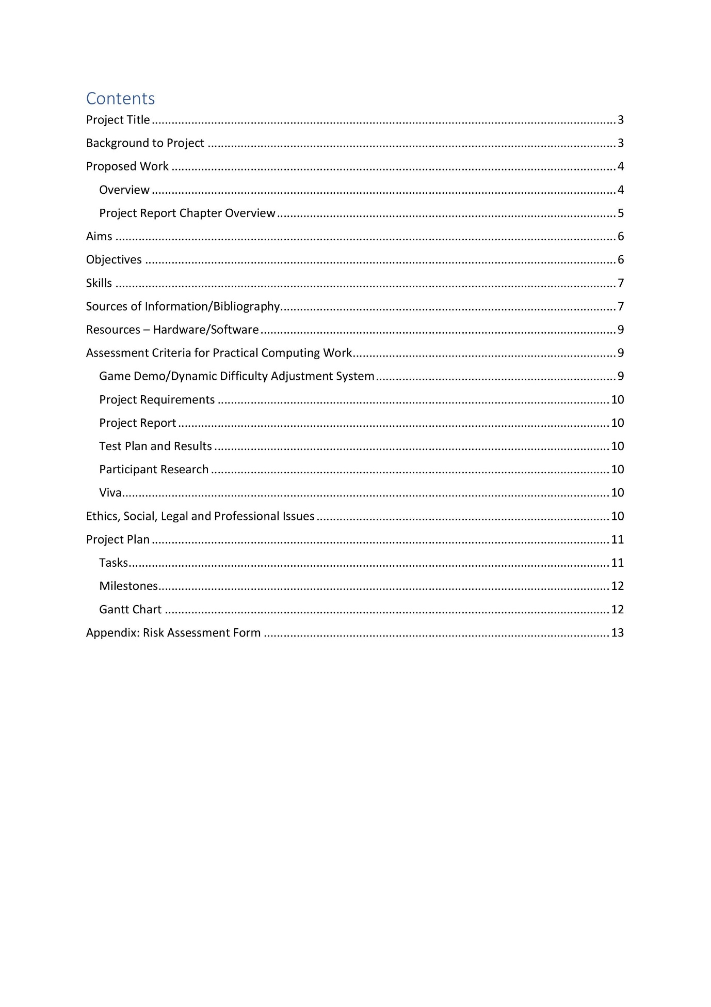

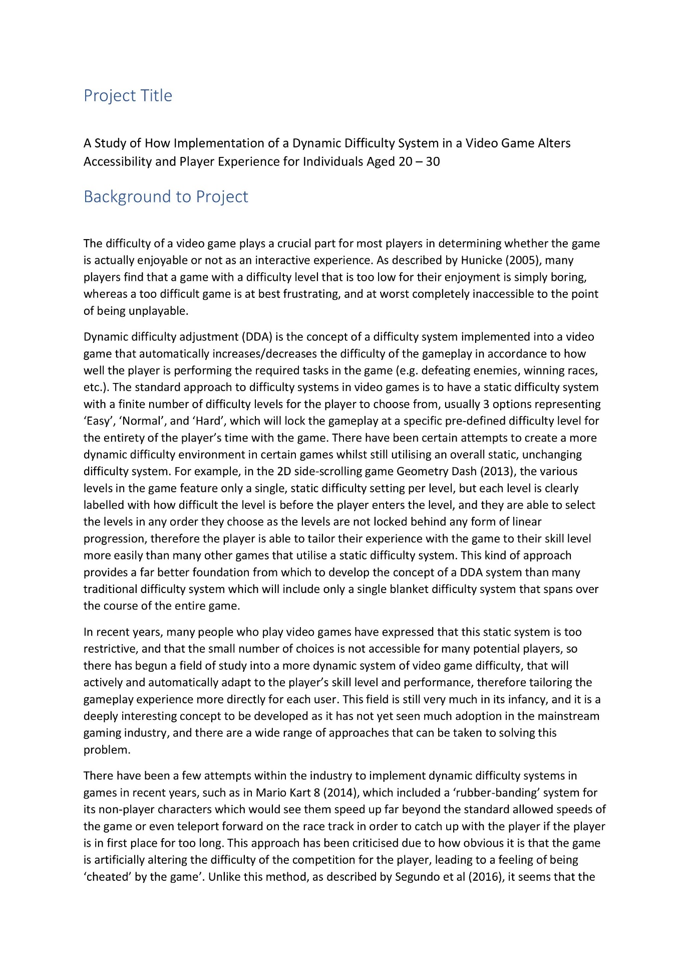

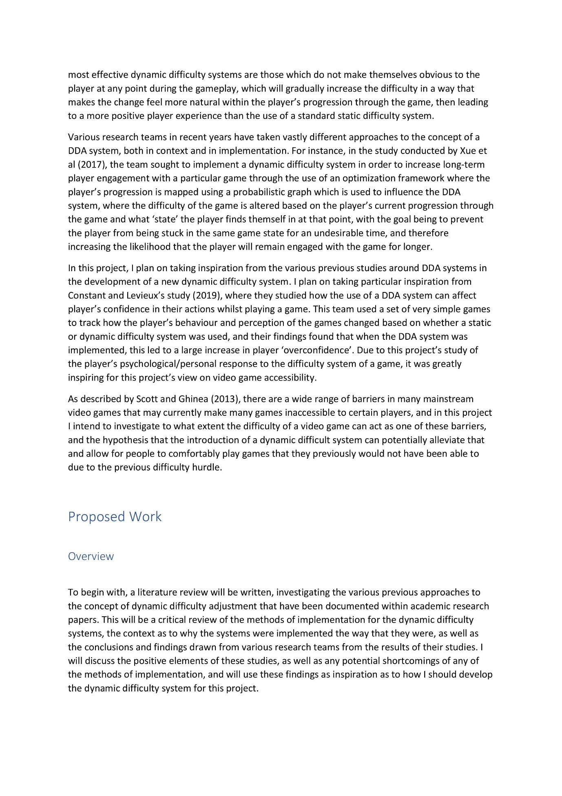

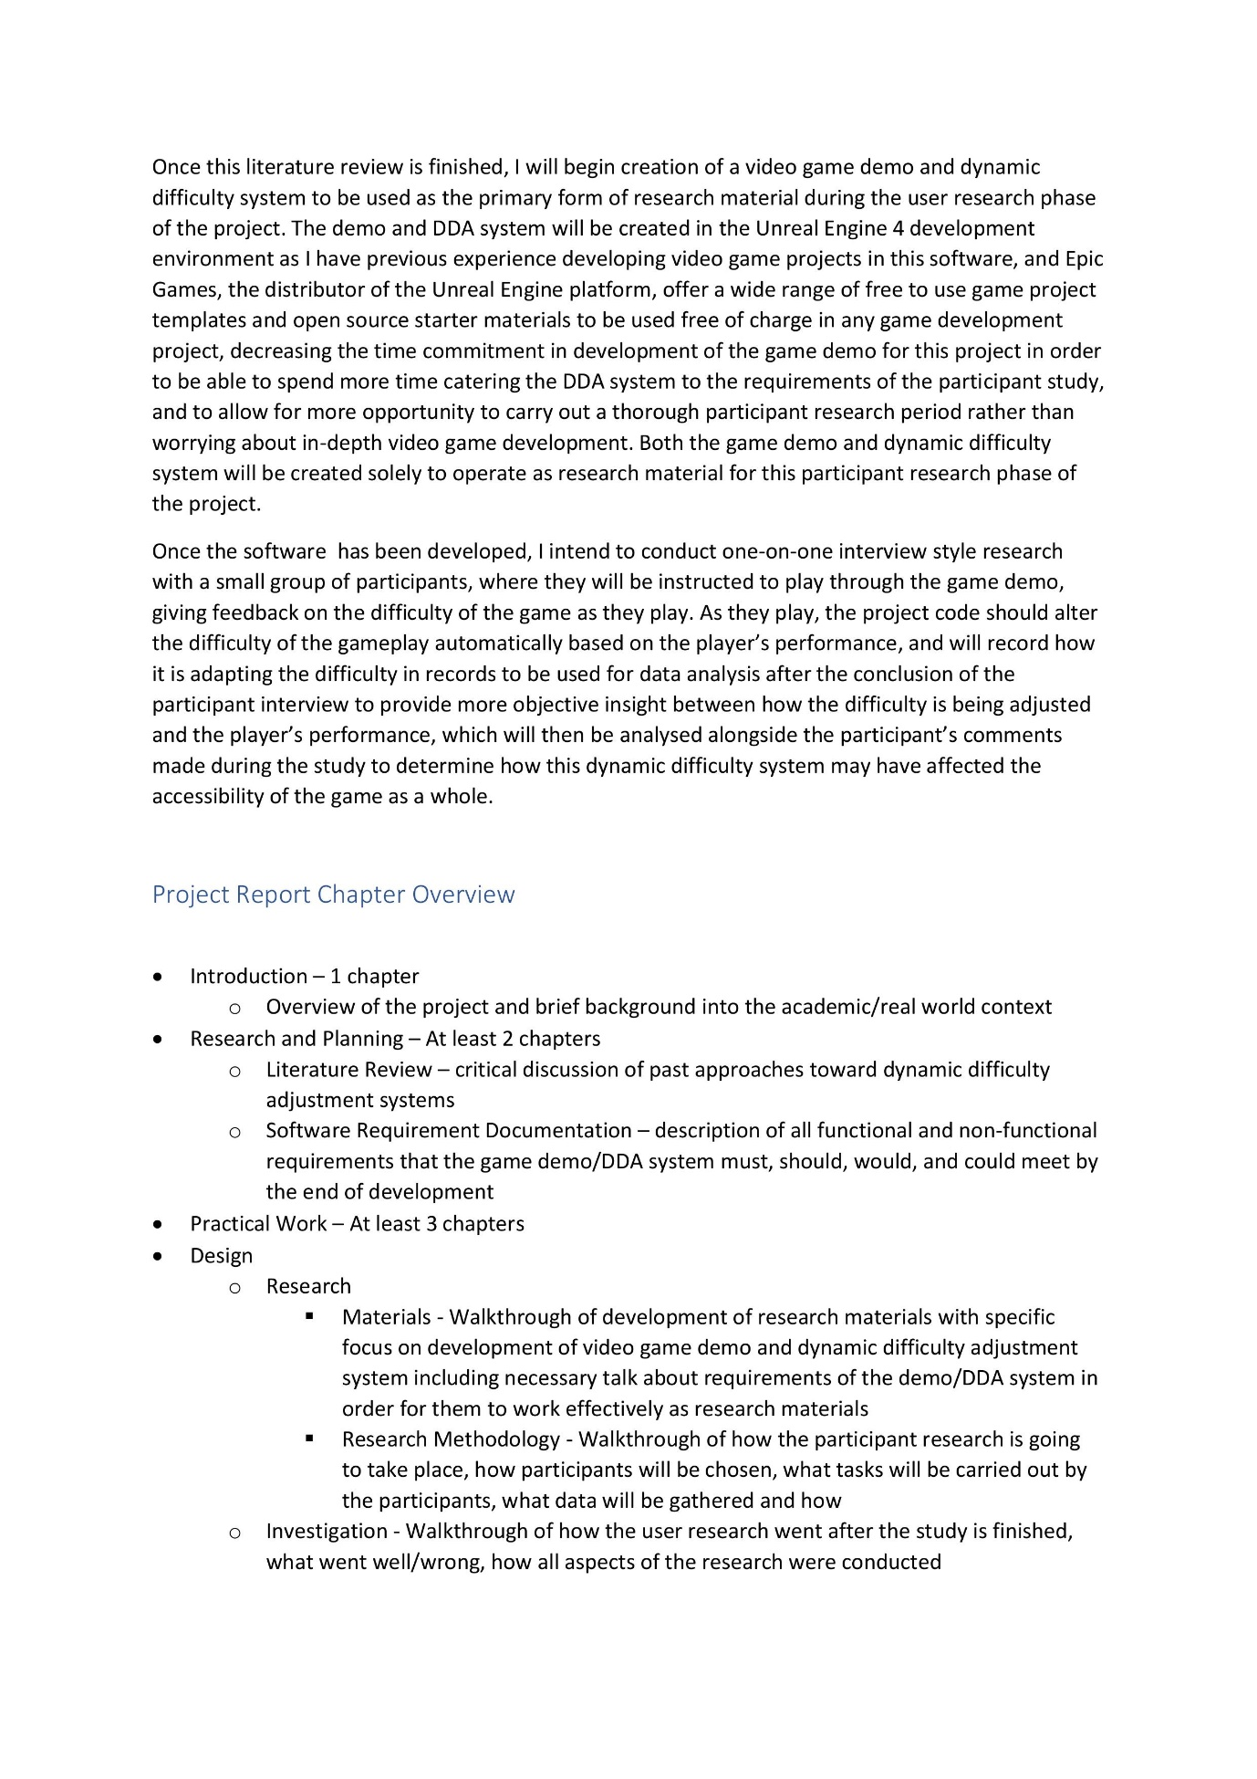

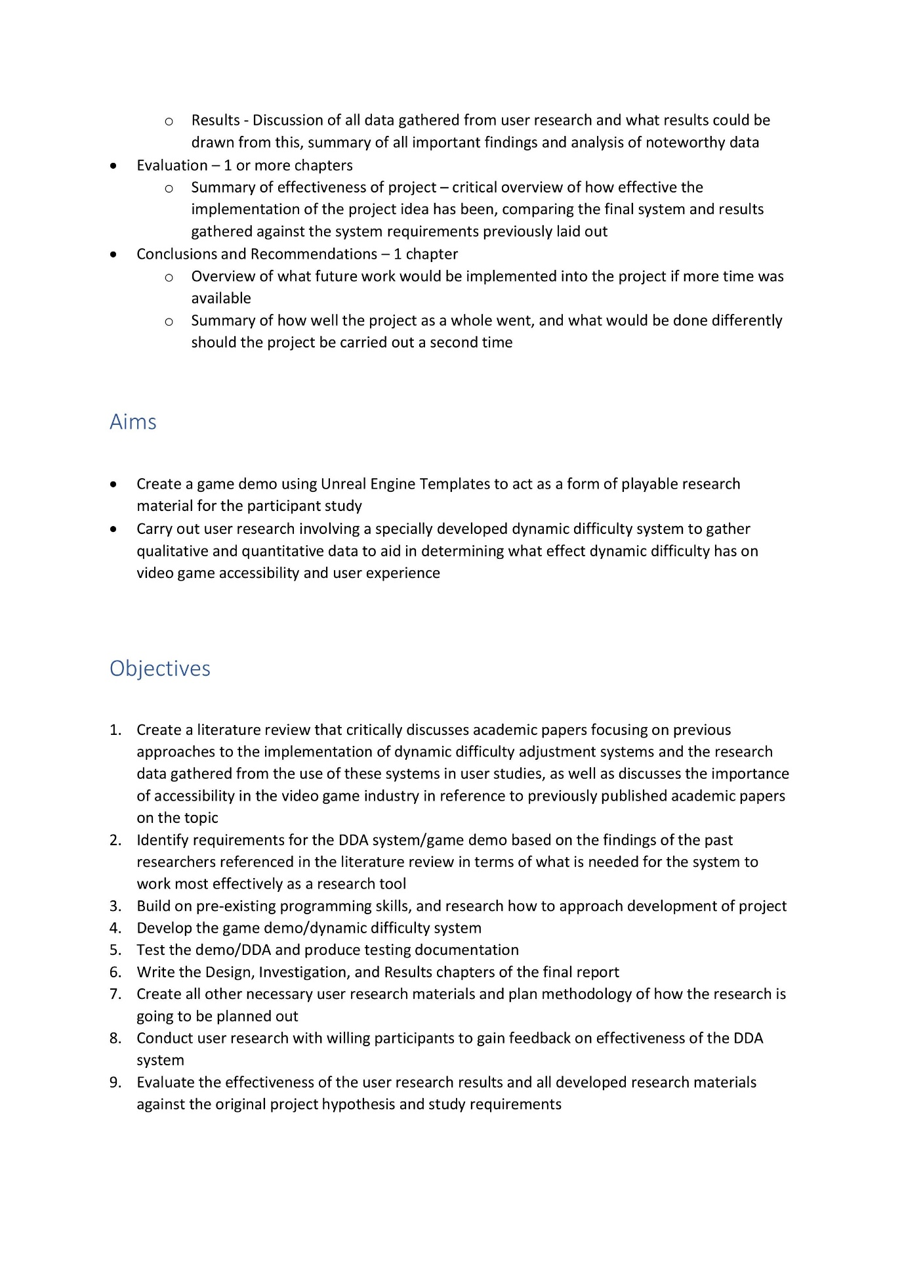

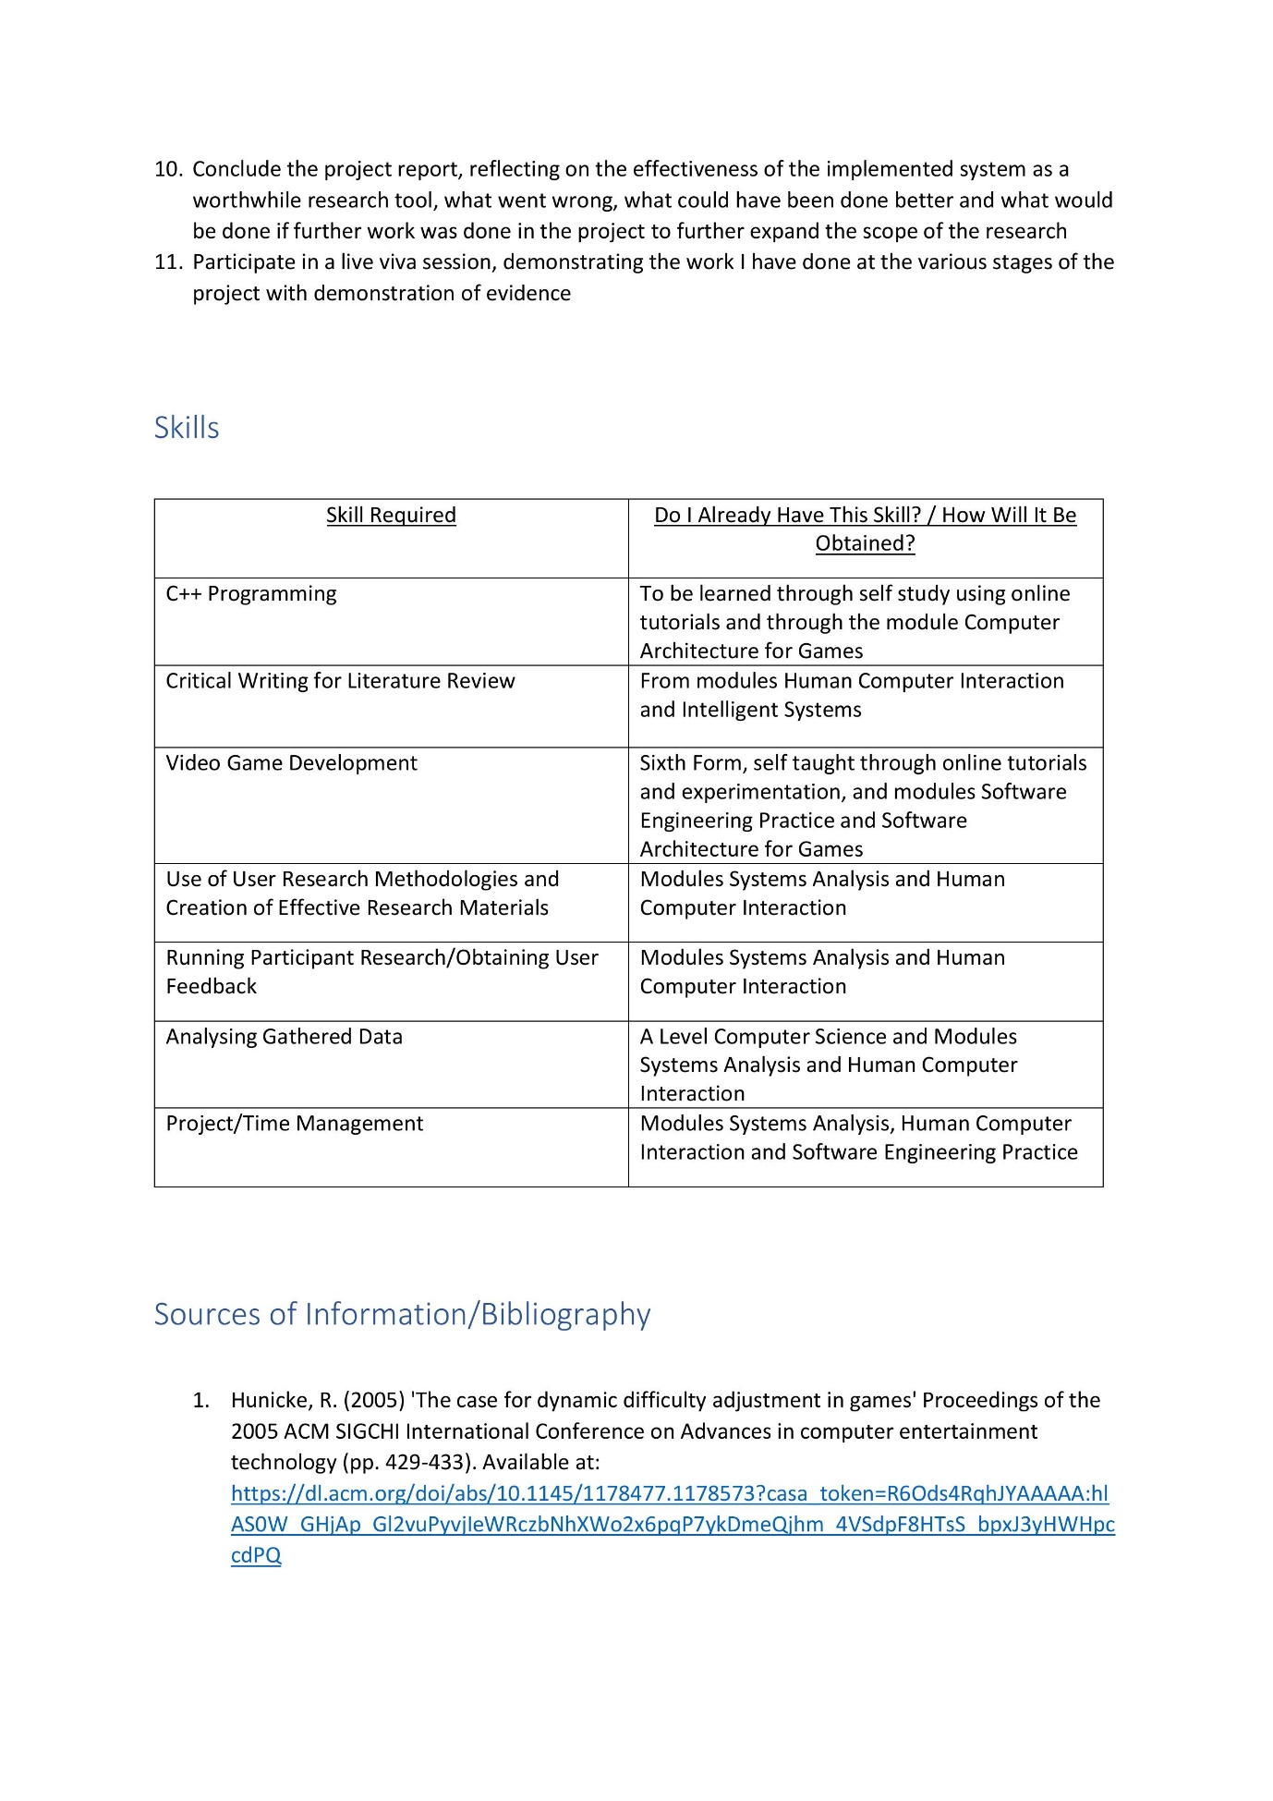

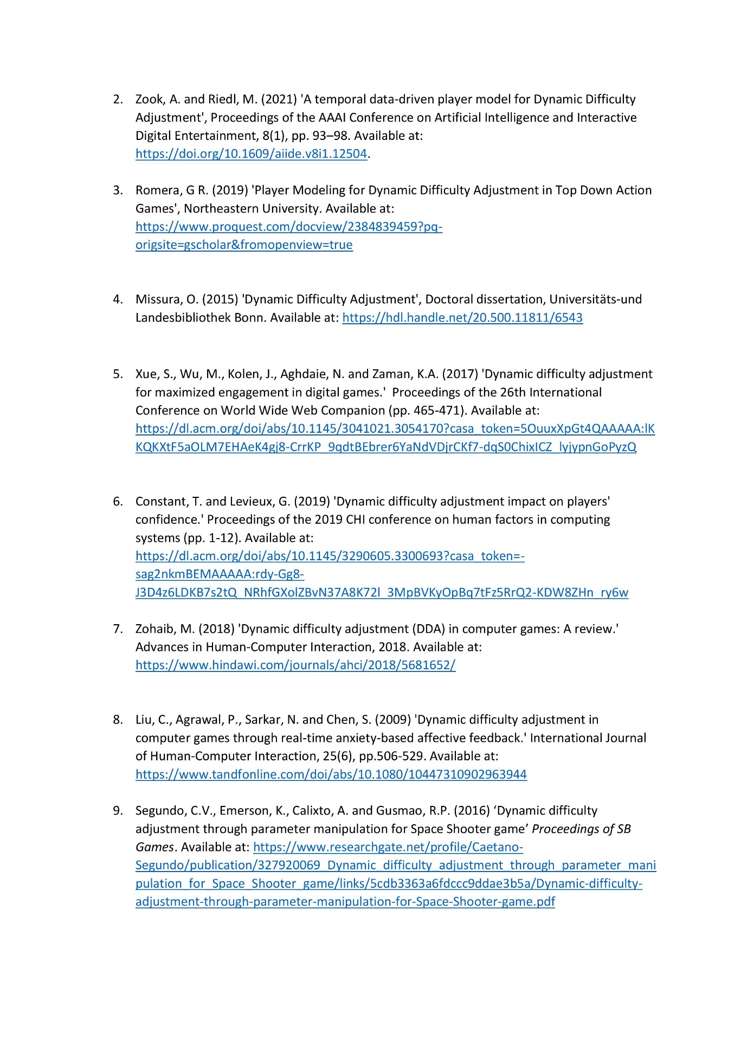

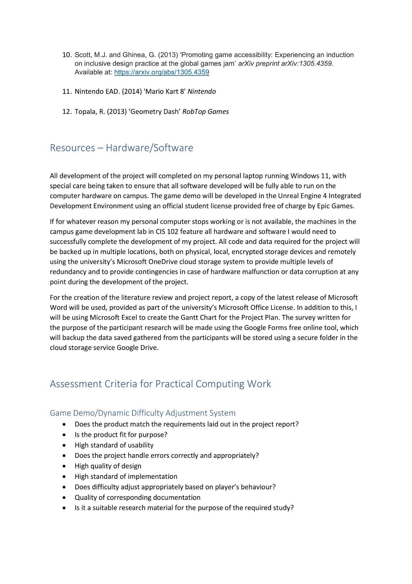





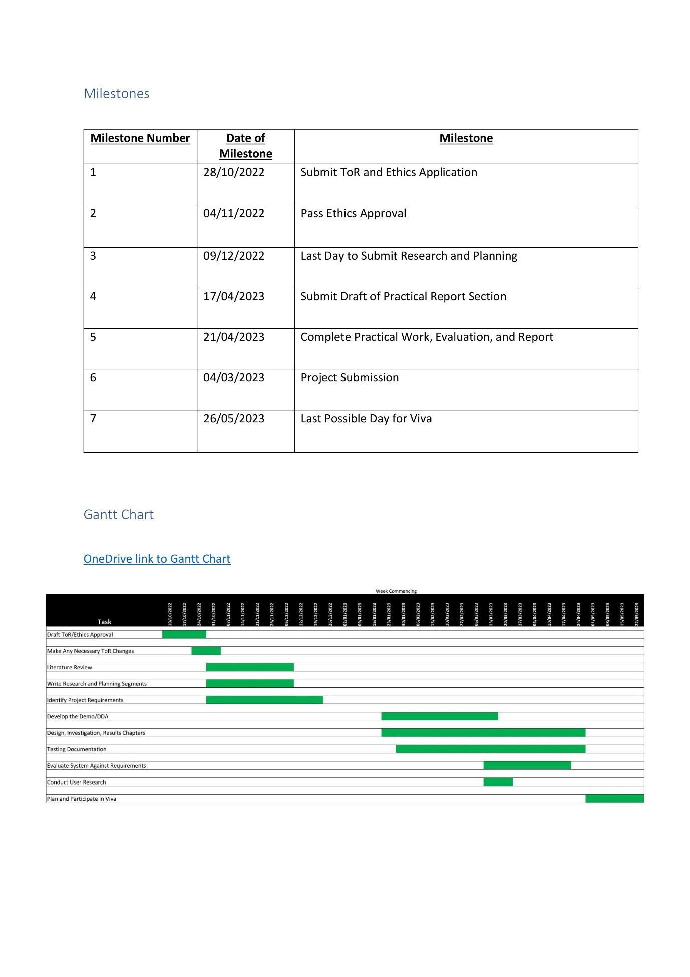







## Appendix 2 – Game Demo Research Material

[OneDrive link to practical work deliverables folder](https://livenorthumbriaac-my.sharepoint.com/:f:/g/personal/w20003739_northumbria_ac_uk/EsnyQdyfypJIlGJ-BTElqEwBT02mRWjMryZEknCoSRAQiw?e=bXhhL9) – https://livenorthumbriaac-my.sharepoint.com/:f:/g/personal/w20003739_northumbria_ac_uk/EsnyQdyfypJIlGJ-BTElqEwBT02mRWjMryZEknCoSRAQiw?e=bXhhL9

[OneDrive link to the Game Demo files](https://livenorthumbriaac-my.sharepoint.com/:f:/g/personal/w20003739_northumbria_ac_uk/EiMdSTvZqABEvROcSOR1yhYBzv4BGYRDxLEPK-86b081CA?e=kICeYQ) – https://livenorthumbriaac-my.sharepoint.com/:f:/g/personal/w20003739_northumbria_ac_uk/EiMdSTvZqABEvROcSOR1yhYBzv4BGYRDxLEPK-86b081CA?e=kICeYQ

### Appendix 2.1 – Game Demo Screen Captures

#### Appendix 2.1.1 – In-Game Starting View



#### Appendix 2.1.2 – Enemy Spawning Code

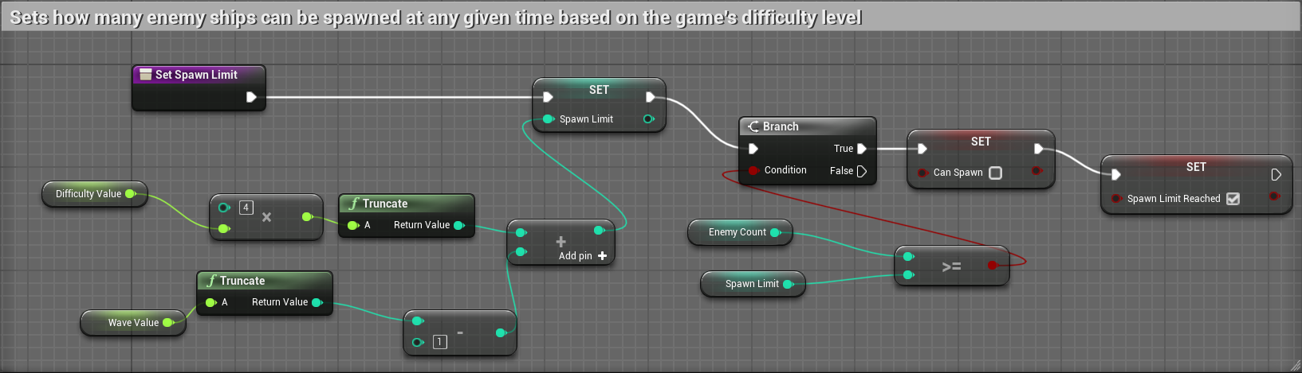

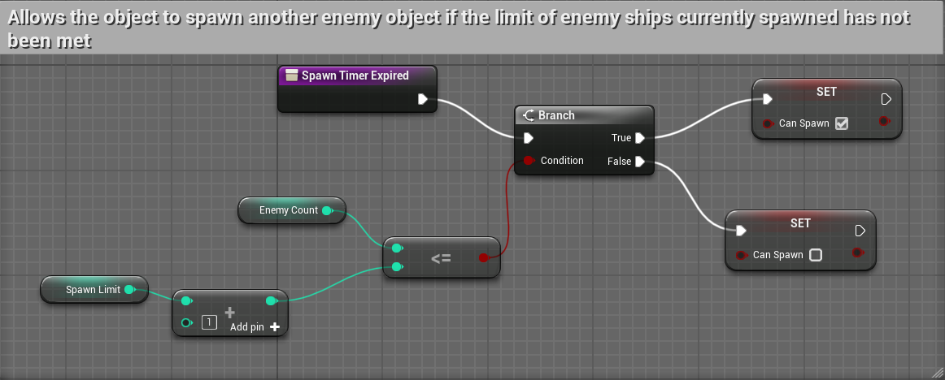

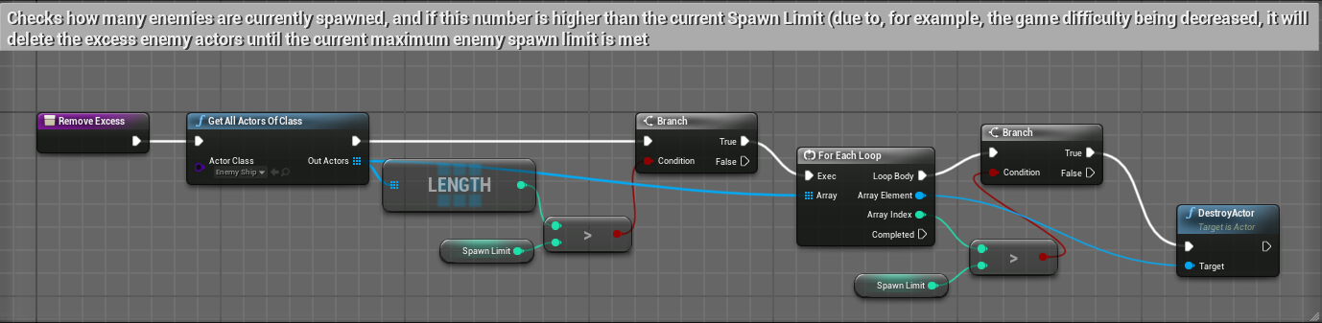

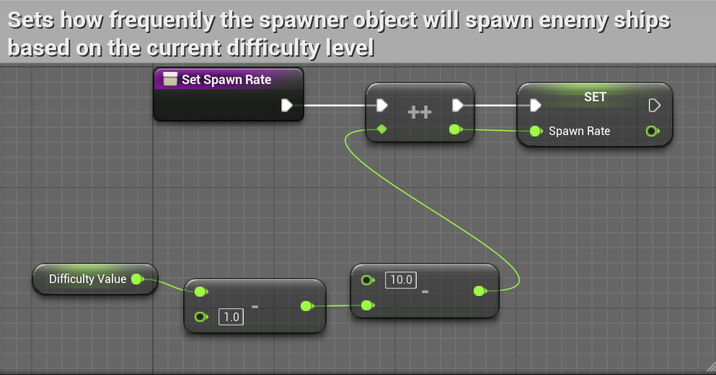

#### Appendix 2.1.3 – Enemy Projectile Code

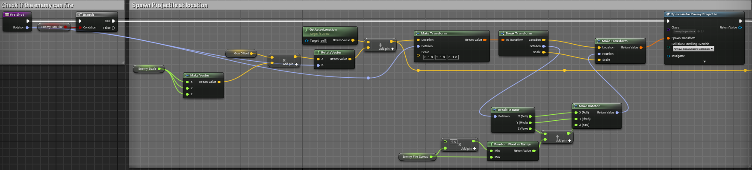

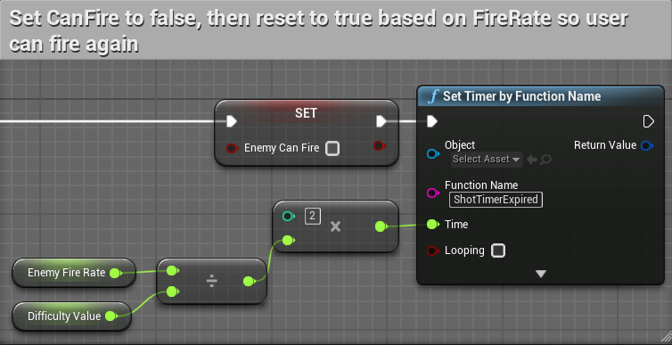

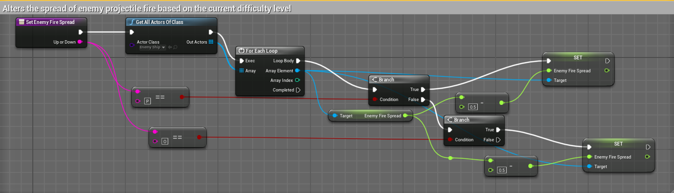

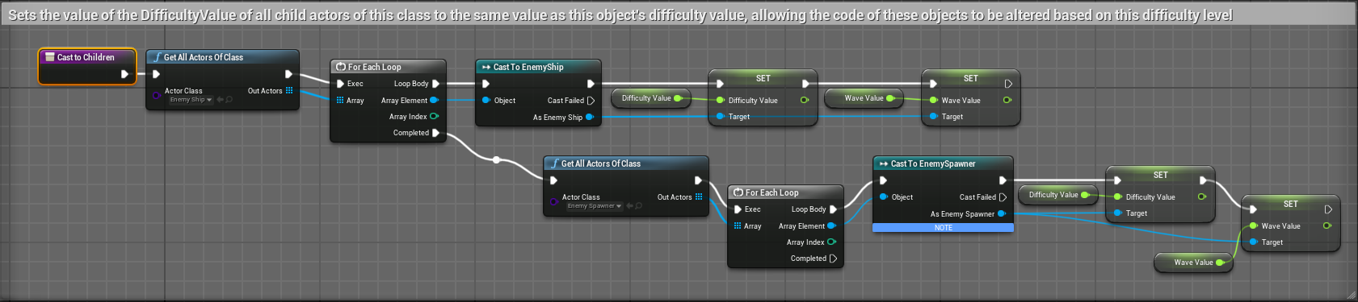

#### Appendix 2.1.4 – Player Life Code

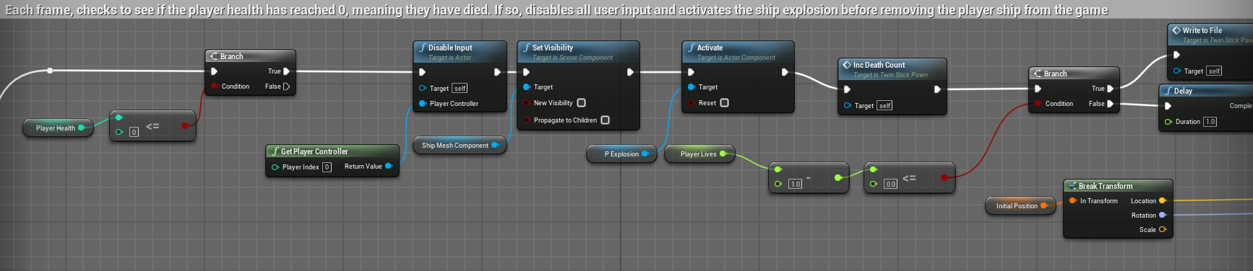

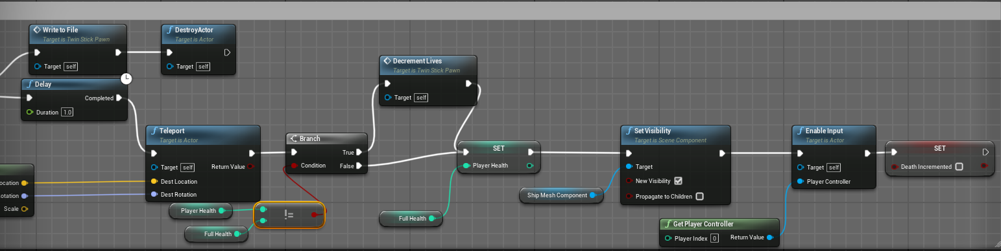

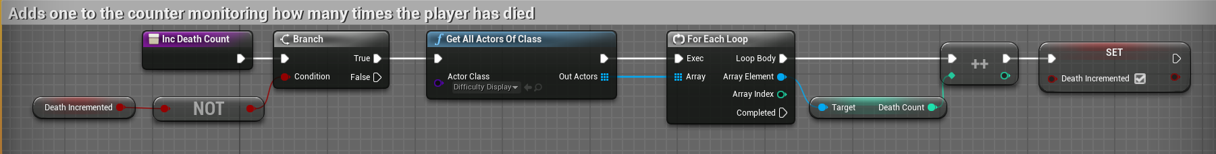

## Appendix 3 – Participant Demographic Survey

### Appendix 3.1 – Demographic Survey Microsoft Forms Link

[Link to Participant Demographic Survey](https://forms.office.com/e/jq34M4CyXX) – <https://forms.office.com/e/jq34M4CyXX>

### Appendix 3.2 – Demographic Survey Responses Link

[Link to Participant Demographic Survey Responses Excel Sheet](https://livenorthumbriaac-my.sharepoint.com/:x:/g/personal/w20003739_northumbria_ac_uk/ET_YiO456QlKkTx_Qx5Zi14B_9uKsp7lBih_04EA-2O0yQ?e=iXzlYO) – https://livenorthumbriaac-my.sharepoint.com/:x:/g/personal/w20003739_northumbria_ac_uk/ET_YiO456QlKkTx_Qx5Zi14B_9uKsp7lBih_04EA-2O0yQ?e=iXzlYO

## Appendix 4 – Game Experience Questionnaire

### Appendix 4.1 – GEQ Microsoft Forms Link

[Link to Game Experience Questionnaire](Link%20to%20Game%20Experience%20Questionnaire) – https://forms.office.com/e/99eDfTTWj6

### Appendix 4.2 – GEQ Responses Link

[Link to Game Experience Questionnaire Responses Excel Sheet](https://livenorthumbriaac-my.sharepoint.com/:x:/g/personal/w20003739_northumbria_ac_uk/EUsXcwGDUV1NqMxE30NFe8kBRdeEtcE4UbmQg5RsVBPuwA?e=MPBLYp) – https://livenorthumbriaac-my.sharepoint.com/:x:/g/personal/w20003739_northumbria_ac_uk/EUsXcwGDUV1NqMxE30NFe8kBRdeEtcE4UbmQg5RsVBPuwA?e=MPBLYp

## Appendix 5 – Game-Generated Participant Playthrough Data

[OneDrive link to the data text files](https://livenorthumbriaac-my.sharepoint.com/:f:/g/personal/w20003739_northumbria_ac_uk/EjDUdLEA8ZlDrYyUC9h1QEIBm2RDeGANGJ-O888Gubz5KA?e=Tjn6Zt) – https://livenorthumbriaac-my.sharepoint.com/:f:/g/personal/w20003739_northumbria_ac_uk/EjDUdLEA8ZlDrYyUC9h1QEIBm2RDeGANGJ-O888Gubz5KA?e=Tjn6Zt

### Appendix 5.1 – Participant 1 Data

#### Appendix 5.1.1 – Playthrough 1

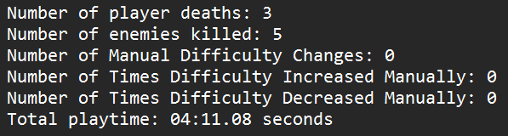

#### Appendix 5.1.2 – Playthrough 2

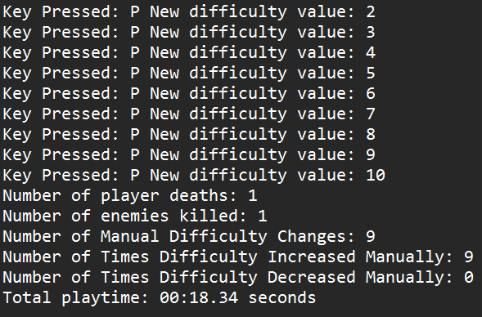

### Appendix 5.2 – Participant 2 Data

#### Appendix 5.2.1 – Playthrough 1

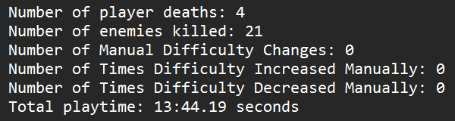

#### Appendix 5.2.2 – Playthrough 2

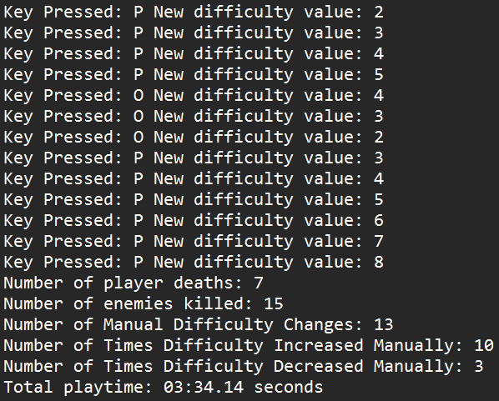

### Appendix 5.3 – Participant 3 Data

#### Appendix 5.3.1 – Playthrough 1

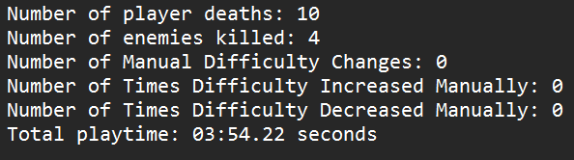

#### Appendix 5.3.2 – Playthrough 2

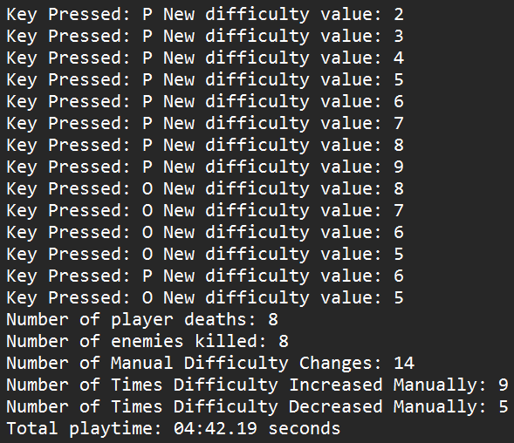

### Appendix 5.4 – Participant 4 Data

#### Appendix 5.4.1 – Playthrough 1

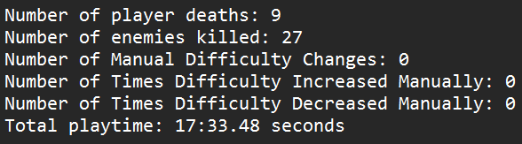

#### Appendix 5.4.2 – Playthrough 2

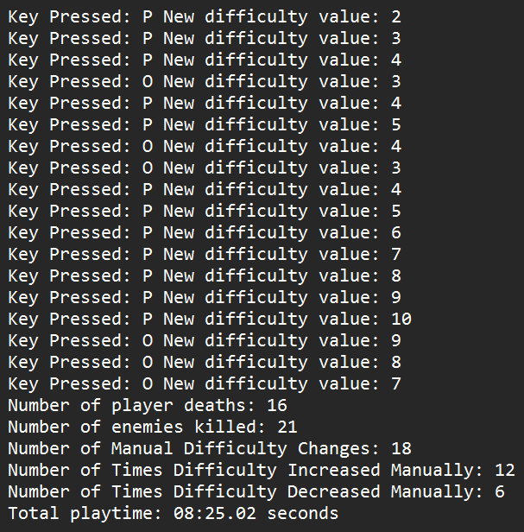

### Appendix 5.5 – Participant 5 Data

#### Appendix 5.5.1 – Playthrough 1

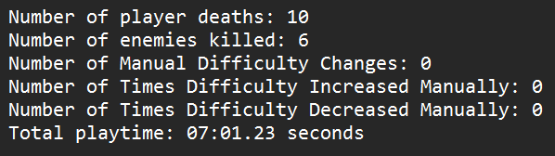

#### Appendix 5.5.2 – Playthrough 2

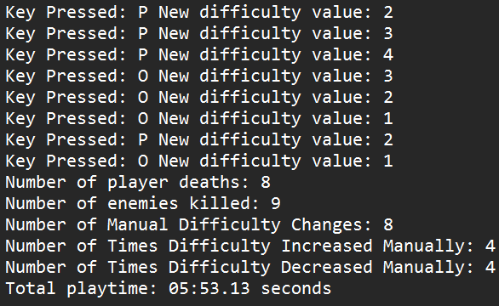

### Appendix 5.6 – Participant 6 Data

#### Appendix 5.6.1 – Playthrough 1

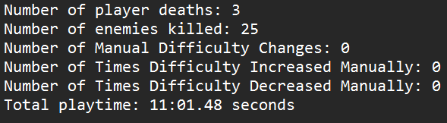

#### Appendix 5.6.2 – Playthrough 2

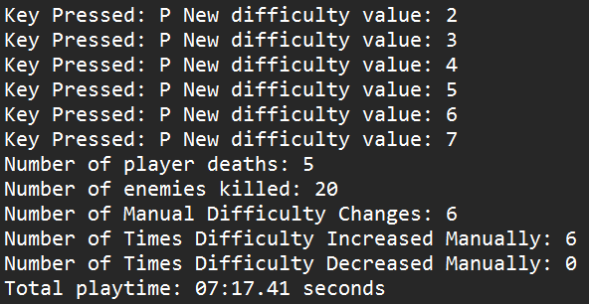

### Appendix 5.7 – Participant 7 Data

#### Appendix 5.7.1 – Playthrough 1

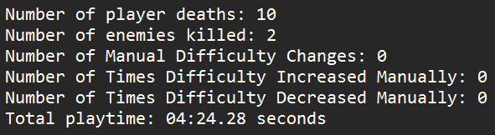

#### Appendix 5.7.2 – Playthrough 2

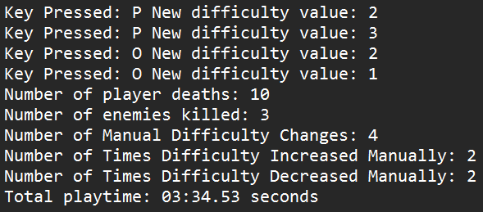

### Appendix 5.8 – Participant 8 Data

#### Appendix 5.8.1 – Playthrough 1

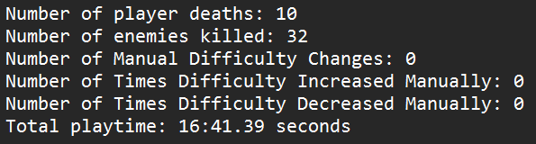

#### Appendix 5.8.2 – Playthrough 2

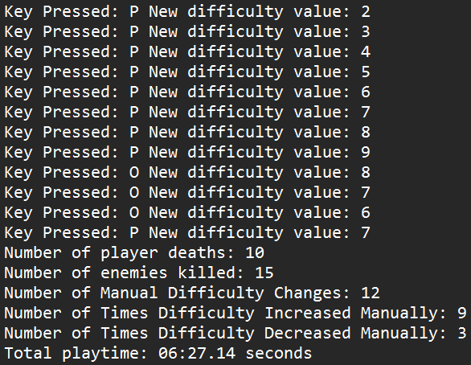

### Appendix 5.9 – Participant 9 Data

#### Appendix 5.9.1 – Playthrough 1

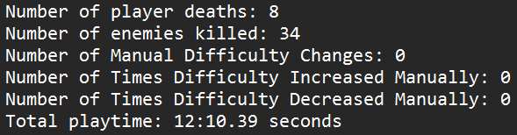

#### Appendix 5.9.2 – Playthrough 2

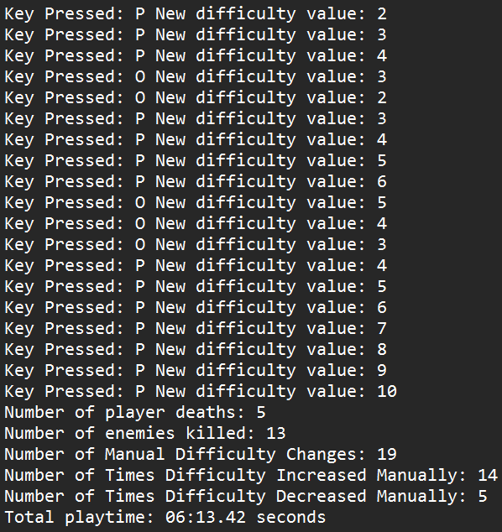

### Appendix 5.10 – Participant 10 Data

#### Appendix 5.10.1 – Playthrough 1

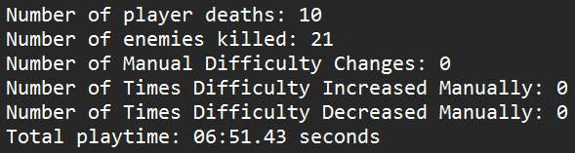

#### Appendix 5.10.2 – Playthrough 2

